**“Meta-Analysis of G-quadruplexes of Dysregulated lncRNAs in Gastric, Head and Neck Cancers Followed by Protein-Interacting Partners Analysis.”**

***Submitted by***

**Janki Kiran Thakkar**

**AU1621051**

**Session: 2016-2021**

***for the partial fulfillment of***

***iMSc in Life Sciences***



**Biological and Life Sciences**

**School of Arts and Sciences**

**Ahmedabad University**

**Ahmedabad-380009**

**Gujarat**

**JUNE 2021**

**WORKPLACE CERTIFICATE**

**Biological and Life Sciences**

**School of Arts and Sciences**

**Ahmedabad University, Ahmedabad**

**CERTIFICATE**

This is to certify that the dissertation entitled **“Meta-analysis of G-quadruplexes of dysregulated lncRNAs in Gastric cancer and Head and neck cancer followed by protein-interacting partners analysis”** submitted by **Ms. Janki Kiran Thakkar, 1621051,** to the Biological and Life Sciences, School of Arts and Sciences, Ahmedabad University, Ahmedabad – 380009, for the degree of **Integrated** **Master of Science** in **Life Sciences** is his/her original work, based on the results of the experiments and investigations carried out independently by him/her during the period **January 2020** to **June 2020** of study under the supervision of **Dr. Bhaskar Datta** at **Indian Institute of Technology, Gandhinagar**.

This is also to certify that the above said work has not been previously submitted for the award of any degree, diploma or fellowship in any Indian or Foreign University.

**Programme Chair Dean of the school of Arts and Sciences**

**CERTIFICATE OF ORIGINALITY AND CONTRIBUTION**

I hereby declare that the project titled “*Meta-analysis of G-quadruplexes of dysregulated lncRNAs in Gastric cancer and Head and neck cancer followed by protein-interacting partners analysis*” is my own original work and that, to the best of my knowledge and belief, it contains no material previously completed or written by another person. This work has not been submitted as a project report at this or any other institution before, except where due acknowledgment is made in the report. Any contribution made to the report by colleagues, with whom I have worked at SAS or elsewhere, during the project, is fully acknowledged.

I also declare that the intellectual content of this report is the product of my own work, except to the extent that assistance from others in the project’s design and conception or in style, presentation and linguistic expression is acknowledged.

Signature:

**TABLE OF CONTENTS**

|  |  |
| --- | --- |
| ACKNOWLEDGEMENTS | 6 |
| ABSTRACT | 7 |
| ABBREVIATIONS | 8 |
| LIST OF FIGURES | 9 |
| AIM AND OBJECTIVE | 11 |
| INTRODUCTION | 12 |
| REVIEW OF LITERATURE | 14 |
| MATERIALS AND METHOD | 33 |
| RESULT AND DISCUSSION | 40 |
| CONCLUSION | 54 |
| FUTURE PROSPECTS | 55 |
| REFERENCES | 57 |

**ACKNOWLEDGEMENTS**

I am very thankful to Indian Institute of Technology – Gandhinagar for giving me the opportunity to learn new skills, grow my knowledge and help me develop as a skilled individual. I extend my gratitude towards Dr. Bhaskar Datta for his valuable guidance and supervision which helped me throughout this project. His constant support and encouragement helped up gain insight of and develop into this new field of study.

I am extremely grateful towards Biological and Life Sciences, School of Arts and Sciences, Ahmedabad University for their faith in me and to allow me to venture into new areas of study and new environments, and to widen my horizons.

I would extend my sincere thanks to Chinmayee Shukla and Shubham Sharma for their help in the laboratory.

Lastly, I would like to thank my friends and my family for their constant encouragement and moral support.

**ABSTRACT**

G-quadruplexes are four-stranded structures formed by guanine-rich DNA or RNA sequences. The association of four guanines by a network of eight Hydrogen bonds generates a planar structure called a G-quartet or G-tetrad and the stacking of several G-quartets forms a G-quadruplex. The development of cancer and neurodegenerative disorders has often been linked to these mechanisms. G-quadruplexes are produced in several oncogenes, and putative quadruplex sites (PQS) can be found in the human genome. Bringing an overview of the current algorithms used to predict G-quadruplex formation, QGRS Mapper and G4 Hunter was utilized. These web-based servers generate detailed information on the composition and distribution of PQS in any nucleotide sequence and provide G-scores of each. After utilizing these tools for analysis, data collection and narrowing down potential G4 rich lncRNAs, the focus was advanced towards databases aimed towards the classification of PPIs (Protein-protein interactions) and their contrasting structural and functional characteristics.

Keywords: G-quadruplexes, putative quadruplex sites, lncRNAs, QGRS Mapper, G4 Hunter.

**ABBREVIATIONS**

|  |  |
| --- | --- |
| DNA | Deoxyribonucleic acid |
| RNA | Ribonucleic acid |
| G4 | G-quadruplex |
| HQ | Hybrid quadruplex |
| H-bond | Hydrogen bond |
| mRNA | Messenger RNA |
| tRNA | Transfer RNA |
| rRNA | Ribosomal |
| PQS | Putative quadruplex site |
| RBP | RNA binding protein |
| lncRNAs | Long non-coding RNAs |
| CD | Circular dichroism |
| NMR | Nuclear magnetic resonance |
| DMS footprinting | Dimethylsulphate footprinting |
| QGRS | Quadruplex forming G-rich sequences |
| PPI | Protein-protein interaction |

**LIST OF FIGURES**

|  |  |
| --- | --- |
| FIGURE-1 | RNA can fold into several secondary structural motifs to fulfill its precise biological role in a specific cellular environment. These include hairpin stem or loops, bulges, three-way junctions, internal loops, pseudoknots, rG4s and i-motifs. |
| FIGURE-2 | Categories of lncRNA. |
| FIGURE-3 | The G4 structure. |
| FIGURE-4 | Differences between DNA G-quadruplex and RNA G-quadruplex. |
| FIGURE-5 | Representation of intramolecular G-quadruplex formed in double stranded DNA, and DNA-RNA hybrid G-quadruplex formed between the nascent mRNA transcript (blue) and the coding strand (non-template strand shown in red). |
| FIGURE-6 | G-quadruplex. |
| FIGURE-7 | G-quadruplex. |
| FIGURE-8 | lnc2cancer 3.0 database user interface. |
| FIGURE-9 | lnc2cancer 3.0 database browse page. |
| FIGURE-10 | List of lncRNAs associated with Gastric cancer obtained from lnc2cancer 3.0. |
| FIGURE-11 | NCBI Nucleotide. |
| FIGURE-12 | QGRS Mapper user interface. |
| FIGURE-13 | RAW/Fasta Sequence View on QGRS Mapper. |
| FIGURE-14 | List of PQS shown in ‘Data view’ of QGRS Mapper. |
| FIGURE-15 | Parameters considered for data collection in Excel. |
| FIGURE-16 | List of sequences uploaded on G4 Hunter |
| FIGURE-17 | G4 Hunter Analysis setting. |
| FIGURE-18 | G4 Hunter Analysis of lncRNA AATBC (Count vs position graph). |
| FIGURE-19 | G4 Hunter Analysis of lncRNA AATBC (Coverage vs position graph). |
| FIGURE-20 | List of G-quadruplexes predicted by G4 Hunter. |
| FIGURE-21 | List of overlapping sequences. |
| FIGURE-22 | Parameters considered for data collection in Excel. |
| FIGURE-23 | Data collection for Gastric cancer. |
| FIGURE-24 | Data collection for Head and neck cancer. |
| FIGURE-25 | Graph showing distribution of all the lncRNAs. |
| FIGURE-26 | Graph showing percentage distribution of all the lncRNAs. |
| FIGURE-27 | Pie chart showing percentage distribution of all the unique lncRNAs. |
| FIGURE-28 | Graph showing distribution of lncRNAs having 4G G-tracts based on  their G-scores. |
| FIGURE-29 | Graph showing distribution of unique lncRNAs having 4G G-tracts based on their G-scores. |
| FIGURE-30 | Graph showing distribution of all the lncRNAs. |
| FIGURE-31 | Graph showing percentage distribution of all the lncRNAs. |
| FIGURE-32 | Pie chart showing percentage distribution of all the unique lncRNAs. |
| FIGURE-33 | Graph showing distribution of lncRNAs having 4G G-tracts based on  their G-scores. |
| FIGURE-34 | Graph showing distribution of unique lncRNAs having 4G G-tracts based on their G-scores. |
| FIGURE-35 | Graph depicting the PQS distribution for Gastric cancer lncRNAs obtained from G4 Hunter. |
| FIGURE-36 | Graph depicting the PQS distribution for Head and neck cancer lncRNAs obtained from G4 Hunter. |
| FIGURE-37 | LncRNome hits for HOXC-AS3. |
| FIGURE-38 | HOXC-AS3 Transcript general information. |
| FIGURE-39 | HOXC-AS3 Transcript sequence and structure. |
| FIGURE-40 | LncTarD hits for HOXC-AS3. |
| FIGURE-41 | Table showing different expressions of HOXC-AS3 and YBX1 in different cancer types. |
| FIGURE-42 | Boxplot display for YBX1. |
| FIGURE-43 | Boxplot display for HOXC-AS3. |
| FIGURE-44 | HOXC-AS3-YBX1 expression correlation heatmap. |
| FIGURE-45 | HOXC-AS3-YBX1 expression scatter plot. |
| FIGURE-46 | Interaction information displayed on NPInter. |
| FIGURE-47 | Information about YBX1 on G4IPDB. |

**AIM AND OBJECTIVE**

With a bigger goal to create a knowledgebase of long noncoding RNAs, which contains detailed information on the distribution of G4 in various cancers, this project was focused on in silico analysis based on tried and tested methods. A list of lncRNAs for Gastric as well as Head and neck cancer was analyzed first in the already available online database, QGRS Mapper and later in G4 Hunter. This study also delves into protein-interacting partners analysis and provides an insight into the multiple databases available for the same.

**INTRODUCTION**

Guanine quadruplexes (G4) are a class of alternative nucleic acid structures that have gotten a lot of attention recently due to their physiological stability and the broad distribution of sequences that can shape G4. A guanine quartet, a planar squared association of four guanines kept together by cyclic hydrogen bonds, is the foundation of guanine quadruplexes. The stability of the G4 is due to the stacking of two or more quartets and the coordination of cations. The existence of G runs is a prerequisite for a nucleic acid sequence to shape G4 and will serve as the foundation for tools to classify quadruplex-forming sequences.

The corpus of publications about guanine quadruplexes is rapidly expanding, and many of these papers provide in vivo evidence of quadruplex-related effects in telomere biology, transcription control, translation and RNA maturation, replication and genomic stability, and replication origin description. Computational approaches to study the frequency of different types of G-quadruplexes in human cancers also allow large-scale and detailed analysis. Although G-quadruplexes have been surveyed in the human genome with many potential techniques, there aren’t many known user-friendly computational tools easily accessible to the layman.

Based on previous studies, critical evidence for the biological significance of G-quadruplexes (G4) has recently emerged. Since these non-canonical structures tend to be involved in a variety of main biological processes, four-stranded G-quadruplex DNA structures are promising drug targets. Given the increasing interest in G4, researchers are investigating accurate tools for predicting the tendency of a given RNA sequence to form G-quadruplexes. Several algorithms, such as QGRS Mapper and G4 Hunter, can predict the likelihood of quadruplex formation. However, a number of studies have established G4 formation for sequences undetected by these tools (false negatives) while a more limited number of articles reported sequences obeying the consensus and still unable to form G-quadruplexes in vitro (false positives).

In this project, efforts were made towards a comparison study, wherein a similar set of sequences were run through two different databases. QGRS Mapper helps in identifying and studying G-quadruplexes, along with providing their G-scores. G4 Hunter takes into account G-richness and G-skewness of a given sequence and gives a score as an output.

A variety of in silico methods have been developed to support the interactions that have been detected by experimental approach. The computational methods for in silico prediction include sequence-based approaches, structure-based approaches, chromosome proximity, gene expression-based approaches, etc. Several in vitro and in vivo approaches resulted in large-scale development of useful tools for the detection of protein-protein interactions (PPIs) between specified proteins that may occur in different combinations. In order to understand the total context of potential interactions, several databases such as LncRNome, LncTarD, NPInter 4.0 (for lncRNA interacting partners) and G4IPDB (for G4 interacting partners) were explored.

**REVIEW OF LITERATURE**

Cancer is a multi-factorial disorder caused by a variety of molecular changes. Changes in cell proliferation, development, replication, and cell death are among the observed results. Altered gene expression is one potential mechanism of disease production, according to global genomic studies and functional assays. Genes are decoded in immature messages in human cells, which must be processed to give rise to functional proteins. Gene expression pathways involve several control steps - DNAs transcribe RNAs, which are composed of sequences that code proteins (exons) and intervening sequences (introns).

Ribonucleic acid or RNA is one of the three major biological macromolecules that are essential for all known forms of life (along with DNA and proteins). A central tenet of molecular biology states that the flow of genetic information in a cell is from DNA through RNA to proteins: “DNA makes RNA makes protein”. [1]

RNA, or ribonucleic acid, is one of the three main biological macromolecules needed for all known forms of life (along with DNA and proteins). The flow of genetic information in a cell is from DNA to RNA to proteins, according to a core tenet of molecular biology: “DNA makes RNA makes protein”. RNA is the “DNA photocopy” of the cell. When a cell requires a specific protein, it activates the gene for that protein (the section of DNA that codes for that protein) and produces several copies of that DNA in the form of messenger RNA or mRNA. In short, RNA expands the quantity of a given protein that can be made at one time from one given gene, and it provides an important control point for regulating when a certain protein gets made and in what quantity. [1]

For many years, RNA was believed to have only three major roles in the cell – as a DNA photocopy (mRNA), a coupler between the genetic code and the protein building blocks (tRNA), and a structural component of ribosomes (rRNA). [1] Recently, however, the realization has occurred that the roles adopted by RNA are much broader and much more fascinating. It is now known that RNA can also act in the form of certain enzymes, called ribozymes, to speed up chemical reactions. RNA also plays a crucial role in regulating cellular processes – from cell division, differentiation and growth to cell aging and cell death. There are important links between RNA and human disease that have been discovered. Some miRNAs have the ability to regulate cancer-related genes in ways that aid tumour growth.

RNA is made up of varying strands of ribose nucleotides (nitrogenous bases bound to a ribose sugar) linked by phosphodiester bonds. Adenine, guanine, cytosine, and uracil, which replaces thymine in DNA, are nitrogenous bases in RNA. The ribose sugar of RNA is a cyclical structure consisting of five carbons and one oxygen. RNA is susceptible to hydrolysis due to the presence of a chemically reactive hydroxyl (-OH) group bound to the second carbon group in the ribose sugar molecule. This chemical lability of RNA, as opposed to DNA, which lacks a reactive -OH group in the same role on the sugar moiety (deoxyribose), is thought to be one of the reasons DNA evolved to be the preferred carrier of genetic material.in most organisms. [2] The structure of the RNA molecule was described by R.W. Holley in 1965.

RNA STRUCTURE

RNA is predominantly a single-stranded biopolymer. Self-complementary sequences in the RNA strand, however, cause intrachain base-pairing and the folding of the ribonucleotide chain into complex structural forms with bulges and helices. The three-dimensional structure of RNA is crucial to its stability and function, as it allows cellular enzymes to bind chemical groups (e.g., methyl groups) to the chain and modify the ribose sugar and nitrogenous bases in a variety of ways. Such changes allow chemical bonds to form between distant regions of the RNA strand, resulting in complex RNA chain contortions that further stabilise the RNA structure. RNAs can also form complexes with molecules known as ribonucleoproteins (RNPs). Many secondary structures have been studied like hairpin loops, pseudo knots, bulges, multiloops etc. [3] A molecule’s function can be associated with its structure. With various new structural properties of the nucleic acid being identified, researchers are venturing into the role these distinct structures might play in the context of gene expression at transcriptional and translational levels, and in the context of genetic diseases and therapeutic models.



FIGURE – 1: RNA can fold into several secondary structural motifs to fulfill its precise biological role in a specific cellular environment. These include hairpin stem or loops, bulges, three-way junctions, internal loops, pseudoknots, rG4s and i-motifs.

*Source: Tassinari M., Richter S. N., Gandellini P.* ***(2021)****, Biological relevance and therapeutic potential of G-quadruplex structures in the human noncoding transcriptome, Nucleic Acids Research (Volume 49, No. 7, Pages 3617–3633).*

LONG NON-CODING RNA

Long non-coding RNAs, or lncRNAs, play an important role in cancer. They are involved in chromatin remodelling, transcriptional and post-transcriptional control, and cross-talk with other RNA organisms through a number of chromatin-based mechanisms. Decoys, scaffolds, and enhancer RNAs are all possibilities for lncRNAs. Many lncRNAs have been found to be functionally linked to human diseases, particularly cancers. [4] Cellular functions such as cell proliferation, resistance to apoptosis, activation of angiogenesis, promotion of metastasis, and evasion of tumour suppressors are all affected by lncRNA dysregulation. [5]

Intergenic lncRNAs (lincRNAs), intronic lncRNAs, antisense lncRNAs (aslncRNAs), bidirectional lncRNAs, and enhancer RNAs have all been mechanistically characterised in mammals and can be differentiated by their biogenesis loci (eRNAs). [5] They are transcribed by RNA polymerase II and go through similar processes to mRNAs (e.g., splicing, polyadenylation, and 5′ capping), as well as tissue-specific expression and transcription factor regulation. To this end, lncRNAs are processed in various ways during biogenesis to produce mature lncRNAs.

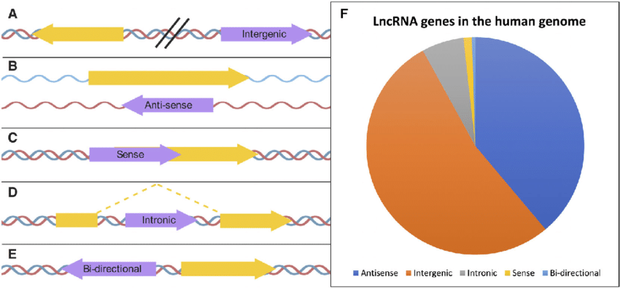

FIGURE – 2: Categories of lncRNA.

*Source: Tsagakis I. & Douka, K., Birds I., Aspden J.* ***(2020)****, Long non-coding RNAs in development and disease: conservation to mechanisms: Long non-coding RNAs in development and disease, The Journal of Pathology.*

CANCER‑RELATED LONG NON-CODING RNA

The role of lncRNAs in development and cellular differentiation has been investigated in disease state studies, and a significant link between cancer and lncRNAs has been discovered. The expression levels of lncRNA in adjacent normal tissues and cancer tissues, as well as normal and cancer cell lines, must be compared using reverse transcription-quantitative polymerase chain reaction to investigate the connection between a specific lncRNA and a specific form of cancer (RT-qPCR). In vitro and in vivo assays, such as cell proliferation, migration, invasion, apoptosis, and cell cycle assays, can be used to determine the function of lncRNA in tumour progression. [4] Statistical analysis can also be looked into to investigate the association between lncRNA expression levels and the overall survival rates of cancer patients. When it comes to gastric cancer, for instance, HOXC-AS3 potentially regulates a group of genes related to cell proliferation and migration of GC, including MMP7, WNT10B, HDAC5 and others, by binding to YBX1. [6] Taurine-upregulated gene 1 (TUG1) is overexpressed in esophageal squamous cell carcinoma (ESCC) tissues, and silencing TUG1 in vitro with siRNA prevents ESCC cell proliferation and migration, as well as the cell cycle progression. [7] LINC00152 can also be found in cancer patients’ plasma, and plasma LINC00152 levels have been found to be substantially higher in gastric cancer (GC) patients. Gastric adenocarcinoma predictive long intergenic noncoding RNA (GAPLINC) regulates CD44-dependent cell invasiveness and is linked to a poor GC prognosis. CD44 is a molecular decoy for miR211-3p, a miRNA that targets CD44 and GAPLINC, and GAPLINC controls it. [7] A number of lncRNAs have also been identified to be abnormally expressed in gastric cancer and are believed to be involved in chemoresistance via regulation of different target genes. Several oncogenic lncRNAs, such as prostate cancer-associated transcript 1 (PCAT-1), BCAR4, SNHG5, GHET1, HOTAIR, plasmacytoma variant translocation 1 (PVT1), metastasis-associated lung adenocarcinoma transcript 1 (MALAT1), urothelial carcinoma-associated 1 (UCA1) and nuclear paraspeckle assembly transcript 1 (NEAT1), as well as some tumor suppressor lncRNAs, have been shown to participate in gastric cancer chemoresistance. [3] These are very similar to the major lncRNAs expressed in Head and Neck cancer, namely, HOTAIR, H19, MALAT1, MEG3, PTENP1, PANCR, etc. [8]

G – QUADRUPLEX STRUCTURES

One such variation of the DNA helix is the DNA quadruple helix structure. The G-quadruplex structure was first observed in 1910. The identification of DNA structures with high guanine association became evident in the 1960s. These DNA structures were four-stranded and had high guanine association. In 1962, Gilbert et al. proposed a planar tetrameric helical arrangement of guanylic acid stacked on each other based on the optical rotation of gels and X-ray diffraction pattern of the gel formed by 5’ GMP (Guanosine Monophosphate). The presence of these structures in eukaryotic telomeric regions was discovered later in the 1980s. G-rich regions in DNA/RNA have the ability to fold into non-canonical quadruplex structures, as was found during chemical studies and evaluation. The Hoogsteen hydrogen bonds between four guanines form a G-quadruplex (G4) structure when two or more G-tetrads stack on top of one another. [1] Following that, various studies such as CD and NMR were used to determine the structure of the G-quadruplex. Because of the structural polymorphisms of these non-canonical structures, the G-quadruplexes appeared in a variety of topologies and arrangements.



FIGURE – 3: The G4 structure: (A) Chemical structure and (B) schematic illustration of a G-tetrad (in purple), composed of four Gs linked together through Hoogsteen H-bonds; (C) example of intramolecular parallel G4. Cations coordinated at the centre of the tetrad are represented in grey, while the Gs are in blue.

*Source: Tassinari M., Richter S. N., Gandellini P.* ***(2021)****, Biological relevance and therapeutic potential of G-quadruplex structures in the human noncoding transcriptome, Nucleic Acids Research (Volume 49, No. 7, Pages 3617–3633).*

In the human genome, there are approximately 3,76,000 putative quadruplex-forming sequences. Next-generation sequencing was used to map endogenous DNA G-quadruplexes in genomic DNA, revealing a cell-type and cell-state specific function. [9] G-quadruplexes were first found in the telomeric regions of chromosomes, where they were thought to block the telomerase enzyme’s function. There is a clear correlation between G-quadruplexes and increased or decreased transcription levels. In contrast to the rest of the genome, G-quadruplexes are slightly more abundant in gene promoter regions (1kb upstream of the transcription start site (TSS)), with >40 percent of gene promoters containing one or more quadruplex motif. G-quadruplexes can play regulatory roles in DNA replication and transcription based on their interactions with other genome elements and proteins.

The presence of RNA G-quadruplexes is more likely than that of DNA G-quadruplexes. DNA is double-stranded and base-paired to another strand, while RNA is single-stranded and exits both the nucleus and the cytoplasm, allowing it more dynamic to follow complex higher-order structures. They’re common in RNA’s UTRs, ORFs, and introns. Translation, alternate splicing, 3’ end processing, transcription termination, and other processes are all regulated by RNA G-quadruplexes. Targeting RNA G-quadruplexes is an appealing strategy for drug development against many diseases, including cancer, since many clinically significant RNAs contain G-quadruplex structures.



FIGURE – 4: Differences between DNA G-quadruplex and RNA G-quadruplex.

*Source: Agarwala P., Pandeya S., Maiti S.* ***(2015)****, The tale of RNA G-quadruplex, Organic & Biomolecular Chemistry (Issue 20).*

Apart from pure DNA and RNA G-quadruplexes, Zheng Tan et al. identified a type of G-quadruplex in 2013. This is a DNA-RNA hybrid that forms in the cell during transcription and is also known as DNA-RNA Hybrid G-quadruplex or HQ. The guanines in an HQ come from both DNA and RNA, forming planar G quartets that stack up to form a quadruplex. The non-template strand and the RNA transcript form HQs. As the RNA polymerase sweeps through and begins synthesising the RNA, a portion of the RNA remains attached to the template strand, preventing the two DNA strands from re-annealing. If the DNA non-template strand is G-rich in this case, it can form an intramolecular G-quadruplex (G tracts ≥4 in non-template) or a hybrid with newly synthesised RNA, which will have guanines like the non-template strand (for G tracts ≥2 in non-template).



FIGURE – 5: Representation of intramolecular G-quadruplex formed in double stranded DNA (left), and DNA-RNA hybrid G-quadruplex formed between the nascent mRNA transcript (blue) and the coding strand (non-template strand shown in red) (right).

*Source: Xiao S., Zhang J. Y., Zheng K. W., Hao Y. H., and Tan Z.* ***(2013)****, Bioinformatic analysis reveals an evolutional selection for DNA: RNA hybrid G-quadruplex structures as putative transcription regulatory elements in warm-blooded animals, Nucleic acids research.*

G-QUADRUPLEX STRUCTURE AND TOPOLOGIES

The function of a molecule or a system of molecules is determined by its structure. Synthetic sequences were used in studies to analyse structural aspects and, subsequently, to consider their functional aspects. Due to Hoogsteen bonding, which occurs once the bases are flipped, guanine nucleotides will base-pair with each other. [1] G-quartets are associated with the formation of this. However, G-quadruplexes’ structural features aren’t limited to the creation of G-quartets. In vitro and in vivo, the directionalities, loops, and interactions with other cations all have a significant impact on how a G-quadruplex shapes and behaves.

Adenine forms two hydrogen bonds with Thymine and Guanine forms three hydrogen bonds with Cytosine in Watson and Crick bonding. Each Guanine in a G-rich region is a hydrogen bond acceptor (O6 and N7) as well as a hydrogen bond donor (O6, N1 and N2), forming eight hydrogen bonds through the Watson and Crick (WC) and Hoogsteen edges. The G-quartet is formed by aligning four Guanines in a plane. The G-quadruplex structure is formed when two or more such tetrads interact by π-π stacking. G-quadruplex structures follow a general consensus sequence G≥2NxG≥2NxG≥2NxG≥2, where G represents the Guanines and N represents loops consisting of other nucleotides (A, T, G, C), and X represents the length of each loop. The existence of a central monovalent cation is needed for the formation of G-quadruplexes. This cation interacts with the lone pair on O6 of the guanines to increase the quadruplex’s ionic ability, which would otherwise result in repulsions due to the guanines’ negative phosphate oxygens. K+ comes first, followed by Na+, Cs+, and Li+. Larger cations are not favoured because they prevent the formation of the G-quartet. Since Na+ is more hydrated than K+, K+ preferentially binds to the quadruplex. [9]

The G-quadruplex can be intramolecular, bimolecular, trimolecular or tetramolecular, i.e. the four strands of the structure can be contributed by one, two, three and four strands respectively. The topologies conferred by the orientation of the strand during folding are depicted in these structures. These topologies can be of three most common types: Parallel (the directionality of all four stands is the same), Anti-parallel (the directionality of any two strands is in the same direction, 2+2), Hybrid (directionality same in three strands and opposite in one, 3+1). The topology is also governed by the length and geometry of loops, namely, Lateral loops (connect two adjacent anti-parallel strands), Diagonal loops (connect two opposite anti-parallel strands) and Propeller loops (connect two adjacent parallel strands). The guanines may adopt either syn or anti glycosidic torsion angles and this gives rise to narrow, medium or wide grooves.



FIGURE – 6: G-quadruplex: (i) parallel topology, (ii) 3+1 topology, (iii) adjacent strands in one direction, (iv) opposite strands in one direction.

*Source: Sannohe Y., Sugiyama H.,* ***(2010)****, Overview of Formation of G-Quadruplex Structures.*



FIGURE – 7: G-quadruplex: (A) Tetramolecular G-quadruplex with parallel topology (all strands in same direction), (B) Bimolecular G-quadruplex with anti-parallel topology, (C-F) intramolecular G-quadruplex structures with anti-parallel topology. (B and C) lateral loops, (D) propeller loops (E) two lateral loops and one diagonal loop, (F) propeller loop and two lateral loops.

*Source: Sannohe Y., Sugiyama H.,* ***(2010)****, Overview of Formation of G-Quadruplex Structures.*

The in-vivo formation of both RNA G-quadruplexes is greatly affected by various intracellular factors such as pH, salt concentrations, molecular crowding, etc. [10] Potential G-quadruplex forming sequences may or may not actually fold into a functionally relevant quadruplex in-vivo. The development of small molecules for the stabilisation or destabilisation of G-quadruplexes is an active area of research, as it may have functionally relevant consequences in a disease context. Many methods to study these structures have been developed such as CD, NMR, X-ray crystallography, UV fluorescence, DMS footprinting, Polymerase stop assay etc.

It became important to recognise further G-quadruplexes in the human genome after the discovery of G-quadruplexes in telomeric and immunoglobulin switch regions. The discovery of such putative G-quadruplex sequences (PGQS) could provide knowledge about and a basis for targeting these in the context of therapeutics, so knowing its prevalence was crucial. It became easier to research PGQS in the genome with the development of bioinformatic methods. Quadparser, an algorithm developed by J. Huppert and S. Balasubramanian, defined and counted all PGQS in the genome by taking both strands into account. There were 3,76,000 PGQS in the genome as a result of this. Apart from telomeric regions, they are most commonly evident in promoter regions of genes, 5’ UTRs, nuclease hypersensitive regions and intron sequences.

G-QUADRUPLEX AND CANCER

Cancer biology is inherently complex, and tumour molecular complexity contributes to the disease’s complexity. G-quadruplexes have been an integral part of cancer research in recent years. Because of their impact on transcriptional control and replication, G-quadruplexes are being considered as cancer therapeutics. In many human cancer models, stabilisation of the G-quadruplex in proto-oncogenes has been shown to provide transcriptional regulation, resulting in anti-proliferative and anti-tumor activity. At the translational stage, RNA G-quadruplexes have therapeutic potential. Research is being carried out on various other genes where G-quadruplexes can be targeted as potential cancer therapeutics. [10] [11] [12]

AN IN-SILICO APPROACH

Using a bioinformatic approach to locating G-quadruplex is essentially a problem of trying to predict a three-dimensional folded structure from a linear sequence of bases. Which of the sequences of bases will in reality form quadruplex structures is very difficult to distinguish, given the current lack of information on folding rules. The number of sequences that could theoretically fold into a quadruplex topology is vastly greater than the number for which we have structural data, so it is necessary to use the current structural evidence as a starting point. The searches for potential quadruplex sequences have, so far, begun with what are essentially pattern-matching algorithms. In most studies of biological G4 structures, in silico predictions were combined with biophysical proof of G4 folding in vitro. Computational methods can be a strong predictor of a sequence’s ability to shape G4 structures, and can then be used to differentiate sequences that don’t have that potential from sequences that do. Various search algorithms have been developed based on parameters derived from biophysical studies. While sequence information alone is insufficient to determine if a motif forms a quadruplex, it serves as an initial step for the discovery of new G-quadruplexes, which should be verified using biophysical and biochemical techniques.

QGRS MAPPER

Because of growing evidence for their function in important biological processes and as therapeutic targets, quadruplex structures produced by guanine-rich nucleic acid sequences have received a lot of attention recently. The use of computational methods to research G-quadruplexes allows for a thorough examination of mammalian genomes. There are no established user-friendly tools for computing G-quadruplexes in nucleotide sequences that are easily available. QGRS Mapper is a web-based server created for predicting quadruplex forming G-rich sequences (QGRS) in nucleotide sequences. It’s a user-friendly programme with a lot of features for identifying and studying G-quadruplexes. It analyses genomic sequences generated by the consumer, such as promoter and telomeric regions, as well as RNA sequences. It can also be used to predict the structures of G-quadruplexes in oligonucleotides. For mapping G-quadruplexes in the sense of RNA processing sites, the software allows you to search and retrieve desired gene/nucleotide sequence entries from NCBI databases. This feature is extremely useful for determining the functional significance of the G-quadruplex structure, especially its role in alternative processing-mediated gene regulation. [13]

Telomeres, promoter regions, transcribed, and other biologically significant regions of mammalian genomes include guanine-rich sequences capable of forming G-quadruplexes. DNA replication in the retinoblastoma susceptibility gene (Rb) region may be regulated by G-quadruplex DNA. This structure can regulate cellular proliferation at the telomeric level, as well as oncogenes like c-myc and c-kit, via transcriptional regulation. [13] G-quadruplex formation appears to be regulated by interactions with cellular proteins. Some proteins are known to help stabilize the structure, while others are known to help resolve it. Proteins and chemicals that stabilize the G-quadruplex structure can inhibit telomerase activity and are thus being investigated as anticancer therapeutics. Chemical compounds that inhibit the action of the G-quadruplex helicase may also be able to control cellular proliferation. Because of their ability to transport monovalent anions, G-quadruplexes are being investigated as possible antimicrobial agents.

FMRP binding, mRNA turnover translation initiation, and repression have all been shown to be influenced by G-quadruplex motifs in the RNA. We previously demonstrated that by interacting with the DSEF-1/hnRNPH/H′ protein, a G-rich sequence (GRS) can mediate the 3′ end processing of mammalian pre-mRNAs. Members of the hnRNP H protein family are known to control polyadenylation and splicing events in mammalian transcripts by recognizing G-rich motifs capable of forming G-quadruplexes. Differential gene expression, which is central to many important biological processes, requires controlled RNA processing. Alternative polyadenylation is believed to occur in more than half of human genes. Alternative splicing is believed to occur in over two-thirds of human genes. By interacting with the hnRNP F and H proteins, sequences capable of forming G-quadruplexes located near polyadenylation and splice sites serve as regulators. It needs to be investigated if quadruplex structure plays a direct role in controlling RNA processing events. [13]

Large-scale and comprehensive analyses of mammalian genes are possible using computational approaches to study G-quadruplexes in mammalian genomes. While such techniques have been used to survey G-quadruplexes in the human genome, there are no publicly available user-friendly computational methods. According to QGRS Mapper analysis, however, it has been hypothesized that such motifs are common near alternative splice and poly(A) sites.

G-SCORES

A scoring system that evaluates a QGRS for its likelihood to form a stable G-quadruplex has been devised as part of the database. Higher scoring sequences are predicted to make better candidates for G-quadruplexes. Observations made from various studies show that shorter loops are more common than longer loops, G-quadruplexes tend to have loops roughly equal in size and the greater the number of guanine tetrads, the more stable the quadruplex.

The computed G-scores are dependent on the user selected maximum QGRS length. The highest possible G-score, using the default maximum QGRS length of 30, is 105. Here is a sequence attaining that score: [13]

GGGGGGTGGGGGGTGGGGGGTGGGGGG.

If the positions of two QGRS in the nucleotide sequence coincide, they are said to overlap. Starting with a nucleotide sequence, QGRS Mapper can find all QGRS in the sequence and generate a non-overlapping set of QGRS. By choosing the higher-scoring QGRS, overlaps can be avoided. [13]

For any NCBI nucleotide sequence known or generated, QGRS Mapper generates detailed information on the composition and distribution of putative quadruplex forming G-rich sequences (QGRS). The software is also capable of analyzing mammalian pre-mRNA sequences, including those that have undergone alternative processing (alternatively spliced or alternatively polyadenylated). QGRS Mapper is a user-friendly programme that offers several options for analysis in predicting the ability of a nucleotide sequence to shape G-quadruplex structure. A minimum number of tetrads can be defined along with the maximum length of the G-quadruplex motif, as well as the loops’ size and composition. The software then maps unimolecular QGRS through an entire nucleotide sequence that has been input in a raw or FASTA format. This approach can be used to analyze both genomic and RNA sequences, including promoter and telomeric regions. It can also be used to predict the structures of G-quadruplexes in oligonucleotides. Alternatively, the software allows scanning the entire NCBI Gene Entrez, RefSeq, and GenBank databases to find the gene/nucleotide sequence entries needed to review the transcribed region. QGRS Mapper analysis is a one-of-a-kind method for mapping G-quadruplex forming sequences in RNA processing sites. This feature is extremely useful for determining the functional significance of the G-quadruplex structure, especially its role in alternative processing-mediated gene regulation. QGRS Mapper provides an interactive graphic representation of the data in addition to providing data on the composition and positions of QGRS relative to the processing sites in the pre-mRNA sequence. A graphics module can also help visualize QGRS distribution patterns among all the alternative RNA products of a gene simultaneously on a single screen. [13]

G4 HUNTER

When it comes to computational analysis of G-quadruplexes, there are often limitations. One such limitation is the existence of false negatives and false positives. There have been many described sequences that do not form G-quadruplexes in vitro and vice versa. To overcome these limitations, G4 Hunter was used since it takes into account G-richness and G skewness of a given sequence and provides a score (quadruplex propensity) as an output. Richness reflects the fraction of Gs in the sequence and skew reflects G/C asymmetry between the complementary strands.

Each location in a sequence is given a score between -4 and 4 to account for G richness and G skewness. A and T (neutral or indifferent) receive a score of 0, G receives a positive score, and C receives a negative score. A single G is given a score of 1 to account for G-richness (or C-richness, which refers to G-richness on the complementary strand); each G in a GG sequence is given a score of 2; each G in a GGG sequence is given a score of 3, and each G in a sequence of 4 or more Gs is given a score of 4. The Cs are scored in the same way, but their values are negative. As a result, G rich regions in GC alternating sequences that are likely to form stable duplexes that would compete with G4 formation have a near-zero average ranking. This scoring scheme also allows for scoring of the complementary strand at the same time. (12) The G4Hunter score is the arithmetic mean of this ‘sequence’ of numbers for a given sequence. The G4Hscore is centred on 0 for random sequences by construction, regardless of GC material. This hypothesis was also tested on a variety of genomes with non-random sequences. The human mitochondrial genome, on the other hand, has a non-null average score due to its pronounced GC skewness. The negative value of the light C-rich strand (L strand) is −0.4. [14]

GENOME-WIDE SEARCH

The mean of the scored nucleic acid sequence is computed for a sliding window arbitrary set at 25 nt when analysing a genome-wide. Regions in which the absolute value of the mean score rises above a threshold are extracted. After that, the overlapping area is fused and optimised by eliminating non-G (or non-C) bases at each extremity that may have escaped the windowing threshold process. If the first or last base is a G (or a C), the series may be expanded. The previous and next bases, respectively, are taken into account if necessary to prevent cutting in a G (or C) run during the windowing threshold process. After that, the score of the fused and refined series is calculated once more. When two fused sequences share a G-rich centre that compensates for two less favourable ‘ends’, the new score which be below the threshold. The list of G4FS discovered by G4Hunter with a threshold of x was given the name G4Hx (where x can in theory be between 0 and 4, but with typical values ranging between 1 and 2). The density of G4-forming sequences (G4FS) per kb is determined by dividing the total number of G4FS by the genome length. [14] [15]

PROTEIN-INTERACTING PARTNERS

Protein-protein interactions (PPIs) handle a wide range of biological processes, including cell-to-cell interactions and metabolic and developmental control. Noncovalent contacts between the residue side chains are the basis for protein folding, protein assembly, and PPI. These contacts induce a variety of interactions and associations among the proteins. Based on their contrasting structural and functional characteristics, PPIs can be classified in several ways. On the basis of their interaction surface, they may be homo- or heterooligomeric; as judged by their stability, they may be obligate or non-obligate; as measured by their persistence, they may be transient or permanent. [16] A given PPI could even be a combination of these three specific pairs. Permanent interactions will shape a stable protein complex, while transient interactions will form signalling pathways.

A comprehensive review of authenticated proteins shows that proteins involved in the same cellular processes often associate with one another. PPI analysis is also critical for determining protein function within the cell. The functionality of unidentified proteins can be predicted on the evidence of their interaction with a protein, the function of which is already revealed. The detailed examination of PPIs has expedited the modelling of functional pathways to exemplify the molecular mechanisms of cellular processes.

PPIs have the ability to alter the kinetic properties of enzymes, function as a general mechanism for substrate channelling, build a new binding site for small effector molecules, inactivate or suppress a protein, change the specificity of a protein for its substrate through interaction with different binding partners, and serve a regulatory role at either the upstream or downstream level. [16]

Recently, high-throughput experimental methods such as two-hybrid systems, mass spectrometry, phage display, and protein chip technology have improved PPI data. These experimental resources have been used to build comprehensive PPI networks. Computational analysis of PPI networks is becoming a necessary method for understanding the roles of previously unknown proteins. It is important to establish methods that predict the full range of possible interactions between proteins in order to comprehend the overall background of potential interactions. A number of in silico techniques are used to endorse the associations discovered by the experimental process. The computational methods for in silico prediction include sequence-based approaches, structure-based approaches, chromosome proximity, gene fusion, in silico 2 hybrid, mirror tree, phylogenetic tree, gene ontology, and gene expression-based approaches. Some of the databases included in this study are:

**LncRNome**: The lncRNome is a knowledgebase of long noncoding RNA, which contains detailed information of 17547 lncRNAs. It provides an entire data on lncRNAs that has been sorted based on the chromosome number to which each RNA belongs. The table obtained after search provides the following details:

● Local ID – A unique ID provided to each lncRNA.

● Gene ID - These are the Ensemble gene Ids. The Ids provide a link to the Ensemble Browser.

● Gene name

● Gene Type – The gene can be Antisense, lincRNA, Processed transcript, Sense intronic

● Transcript ID – The RNA transcript ID also provides a direct link to the Ensemble Browser.

● Transcript name

● Transcript Type – The transcripts can be Antisense, lincRNA, Noncoding, Processed Transcript, Retained Intron, Sense Intronic

● HGNC ID – Provides a direct link to the HUGO Gene Nomenclature Committee

● Chromosome number [17]

**LncTarD**: LncTarD provides a user-friendly web interface that allows intuitive browsing, searching, visualization, and retrieval of all disease-associated lncRNA–target regulations in the database. It allows one to browse all experimentally-supported disease-associated lncRNA–target regulations by selecting the lncRNA symbol, lncRNA-mediated regulatory mechanisms, influenced biological functions, and disease names in a pull-down menu. In human diseases, lncRNA-mediated regulatory mechanisms, including transcriptional regulation, epigenetic regulation, chromatin looping, ceRNA or sponge, interaction with mRNA, and interaction with proteins, are provided by LncTarD. It also provides key downstream targets and important biological functions (such as cell proliferation, EMT, and angiogenesis) driven by disease-related lncRNAs. It gives a list of lncRNA–target regulations responsible for drug resistance or sensitivity involving 52 drugs in 41 human diseases with the goal of providing potential lncRNA–targeted strategies for overcoming drug resistance in cancer therapy and all lncRNA microarray. [18] Following certain selections, a list of matched entries is returned. It also provides the statistics of disease-associated lncRNA–target regulations and allows for searching experimentally-supported functional regulation and expression association.

**NPInter**: With the advancement of high-throughput sequencing technology, a number of new methods have been developed to investigate interactions pertaining to RNAs. NPInter was established in order to organize and classify ncRNA interactions and has been actively upgraded and expanded through the years. The former versions already included interactions detected by newly developed methodology and functional modules such as binding prediction and network viewing to facilitate its usage. Visualization modules and predictive scores are also integrated in order to add confidence to the interactions. NPInter 4.0 includes the integration of newly identified ncRNA interactions and even more user-friendly web services.

**G4IPDB**: The Nucleic Acid G-quadruplex Structure (G4) Interacting Proteins Database (G4IPDB) is a comprehensive database of proteins that interact with nucleic acids to form G-quadruplex structures. G4IPDB is the first database to bring together all of the knowledge about this interaction in one place. More than 200 entries in this database contain information about interactions such as interacting protein names and synonyms, UniProt-ID, source organism, target name and sequences, ∆Tm, binding/dissociation constants, protein gene name, protein FASTA sequence, interacting residue in protein, related PDB entries, interaction ID, graphical view, PMID, author’s name, and techniques used. [19] G4IPDB also has a web-based “G-quadruplex predictor tool” that searches for putative G-quadruplex forming sequences in both the sense and anti-sense strands of a given nucleotide sequence and determines the predicted G score. The interaction of proteins and nucleic acids that form G-quadruplex structures may be therapeutically important for a variety of diseases, including cancer and neurological disease, so providing detailed knowledge about their interactions on a single platform could aid in the discovery and creation of new therapeutics.

**MATERIAL AND METHOD**

Computer technology has now become omnipresent. It is used in biology for a broad range of purposes and experimental instruments, including data archiving, data processing, sequence analysis and prediction, and so on. It is an efficient approach for data storage and control, as well as for data interpretation, such as when analyzing a sequence’s data to assess the gene’s biological function.

To obtain a list of lncRNAs in Gastric Cancer and Head and Neck Cancer, the first step is to browse through Lnc2Cancer 3.0, a manually curated database that provides comprehensive experimentally supported associations between lncRNA or circRNA and human cancer.

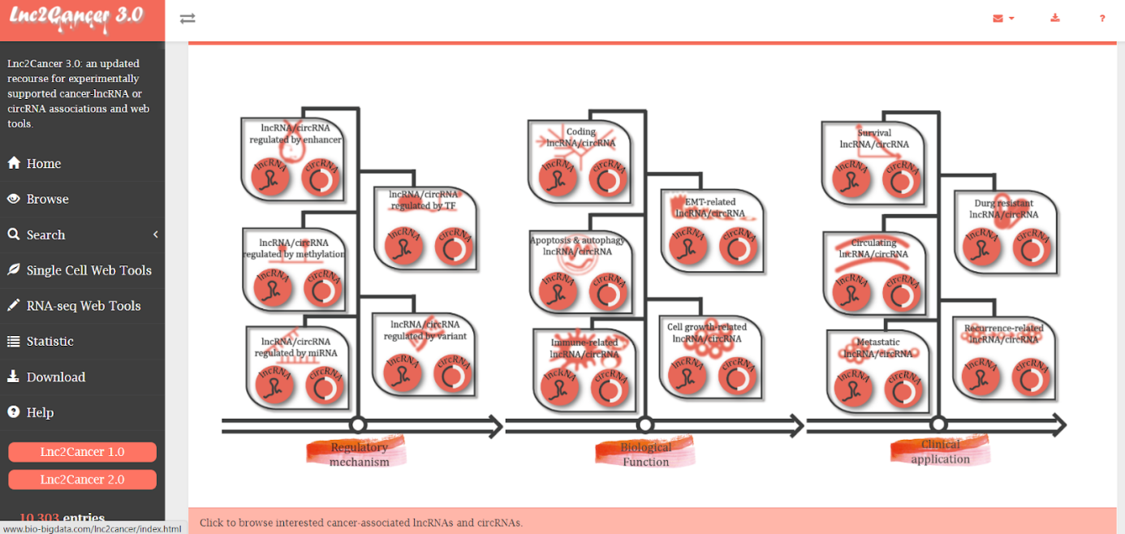

FIGURE – 8: lnc2cancer 3.0 database user interface.

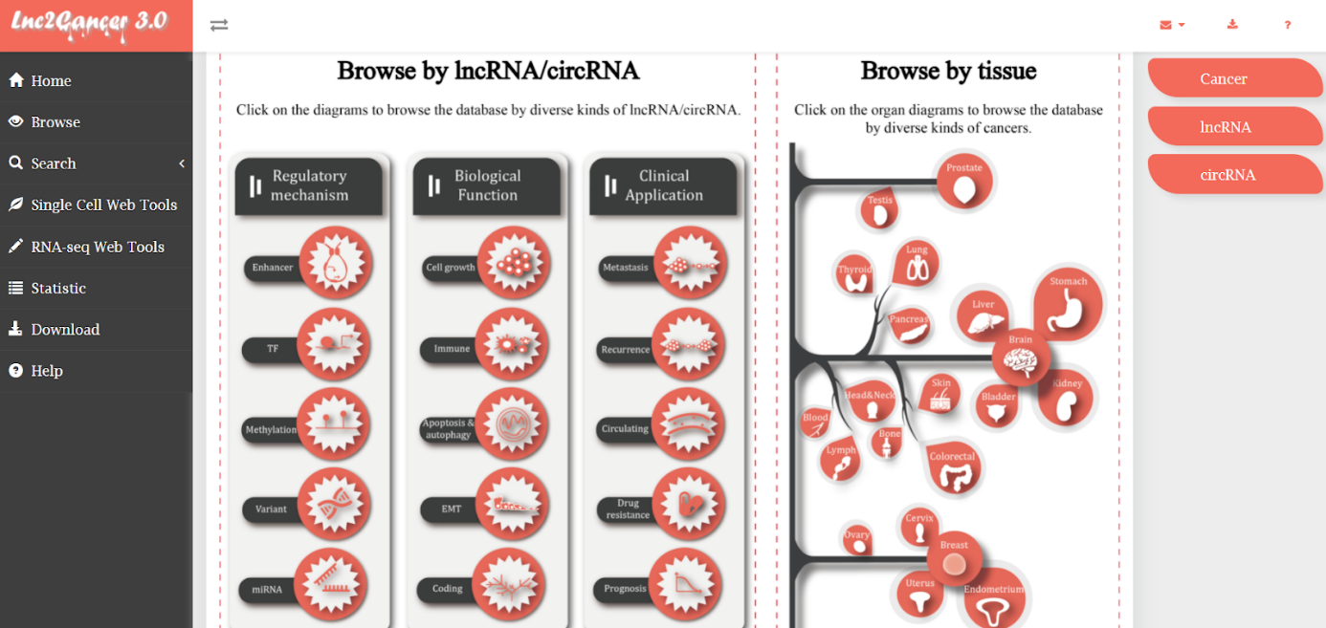

FIGURE – 9: lnc2cancer 3.0 database browse page.

As shown below, a list of lncRNAs can be downloaded as a CSV file or an Excel sheet.

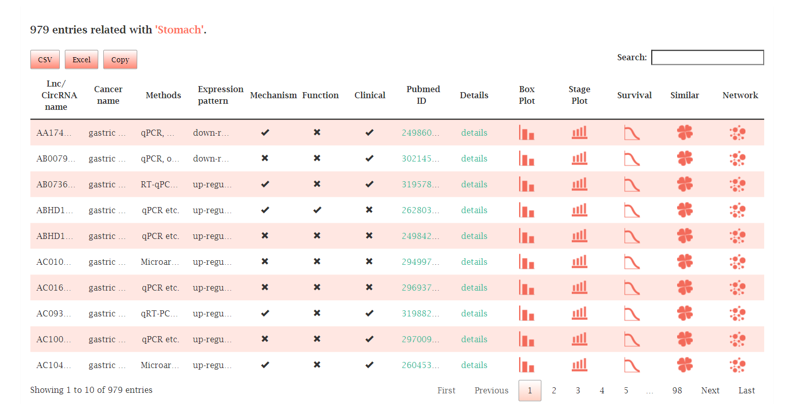

FIGURE – 10: List of lncRNAs associated with Gastric cancer obtained from lnc2cancer 3.0.

A list of 593 and 332 lncRNAs were downloaded for Gastric cancer and Head and neck cancer respectively and transferred to an excel sheet. Each lncRNA, along with all the variants was further analysed on the NCBI database.

NCBI NUCLEOTIDE

Each lncRNA was looked into on NCBI Nucleotide at <https://www.ncbi.nlm.nih.gov/nucleotide/>. Since the requirement was only of long non-coding RNAs in human cancers, appropriate filters were applied, as is shown in the second image below. The first step was to retrieve the raw FASTA format for each variant. The FASTA format is a text-based format that represents either nucleotide or peptide sequences.

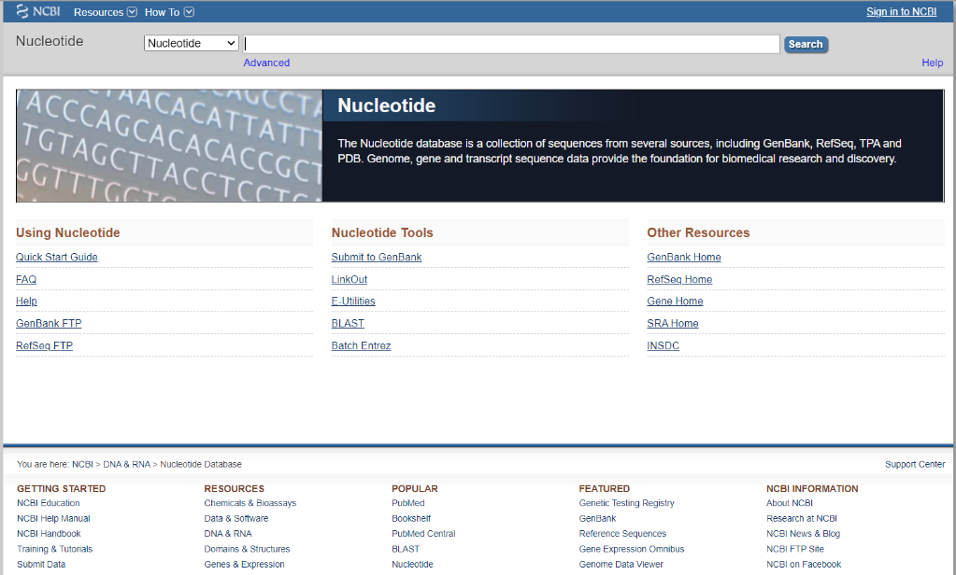 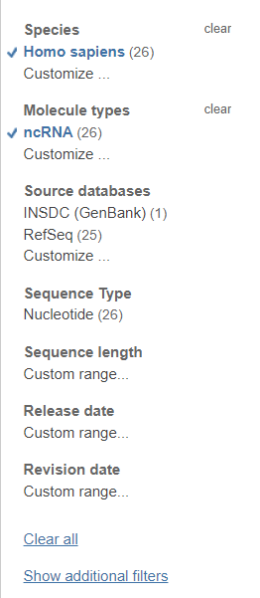

FIGURE – 11: NCBI Nucleotide.

QGRS MAPPER

The abovementioned sequences were then inputted into the QGRS Mapper server at https://bioinformatics.ramapo.edu/QGRS/index.php. The maximum length was kept 45, minimum G-groups at 2, loop size at 0 and loop contain as blank to ensure accuracy.

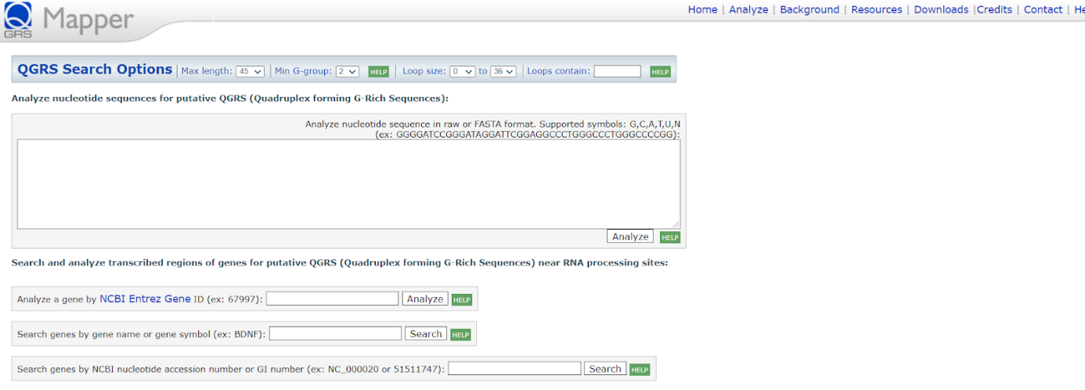

FIGURE – 12: QGRS Mapper user interface.

The QGRS Mapper Analysis Page allows one to enter a nucleotide sequence or to search NCBI for a nucleotide entry that will then be analysed for the presence of QGRS. Upon searching, QGRS Mapper yields the number of quadruplex-forming G-rich sequences. As the algorithm uses the ‘sliding-window approach’ to analyse the sequences, there are some overlaps in the output that the algorithm removes by choosing the higher scoring G-quadruplexes. [13]

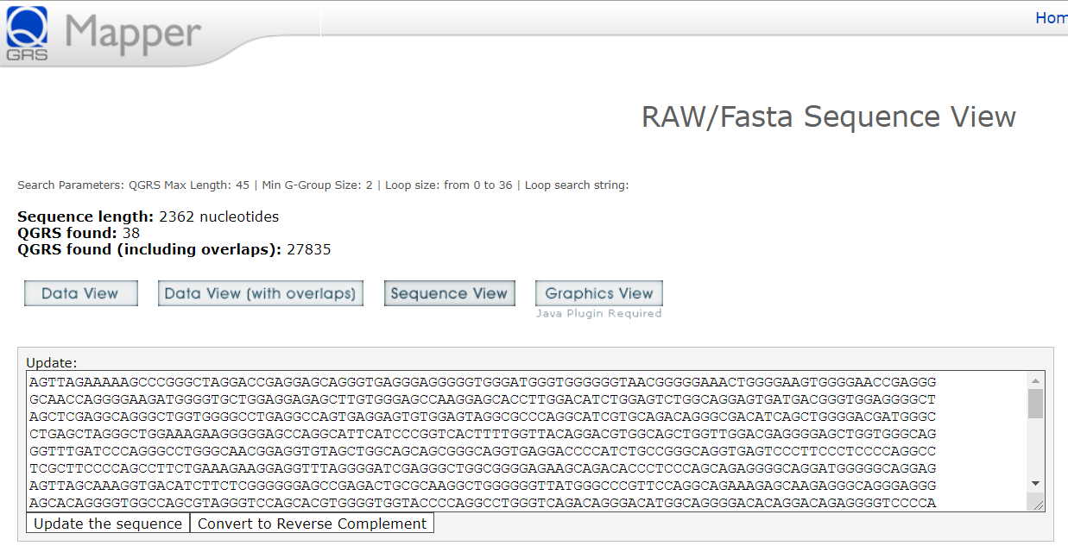

FIGURE – 13: RAW/Fasta Sequence View on QGRS Mapper.

Data view displays a list of all the QGRS sequences, excluding any and all overlaps, that could potentially be present in the given lncRNA sequence. Their position in the lncRNA sequence, sequence length and G-score are also displayed, as in the table shown below.

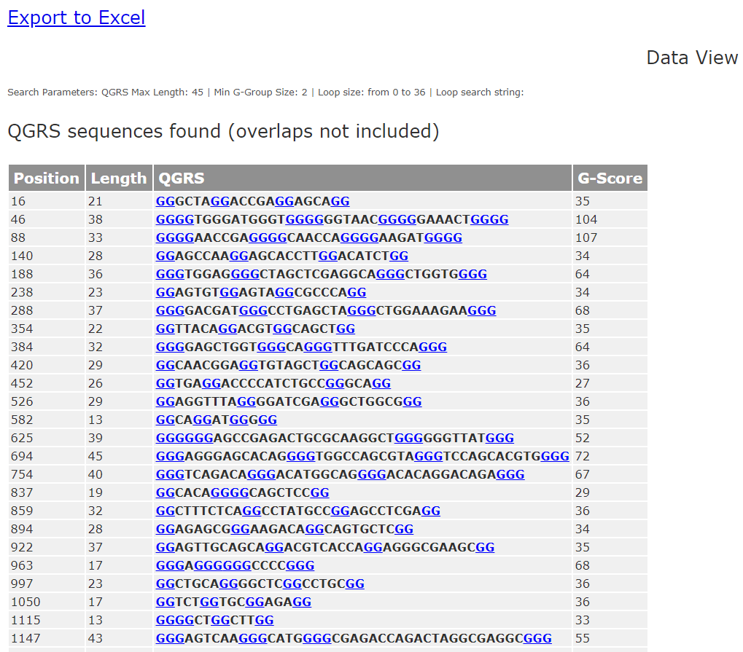

FIGURE – 14: List of PQS shown in ‘Data view’ of QGRS Mapper.

The excel sheet previously downloaded was divided into categories to ensure a detailed analysis would be performed. The goal here was to gather the information at a single location and figure out the number and types of G-tracts (2G, 3G or 4G) in each lncRNA sequence. The following columns were included in the excel sheet:

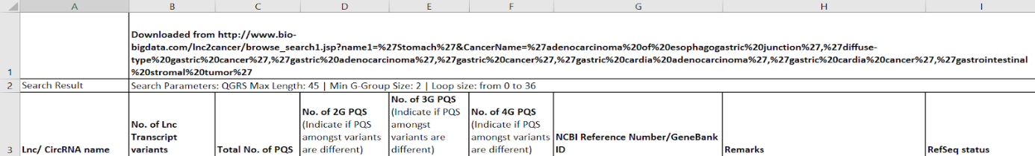

FIGURE – 15: Parameters considered for data collection in Excel.

Only the lncRNAs with a ‘Validated’ or ‘Reviewed’ RefSeq status were further analysed in QGRS Mapper and G4Hunter databases. A total of 263 and 156 sequences were analysed for Gastric cancer and Head and neck cancer respectively.

G4 HUNTER

With the aim to further narrow down the list of long non-coding RNAs for each cancer, G4 Hunter was utilised wherein the input sequence(s) and window size is specified and G4Hunter score threshold, and outputs the sequences and scores are identified. The database also shows a heatmap of quadruplex forming sequences and provides statistical information. Sequences are imported using NCBI ID, with the ability to download multiple sequences from NCBI multiple imports. Another option is to upload a local FASTA or txt file and/or directly paste sequences from the clipboard.

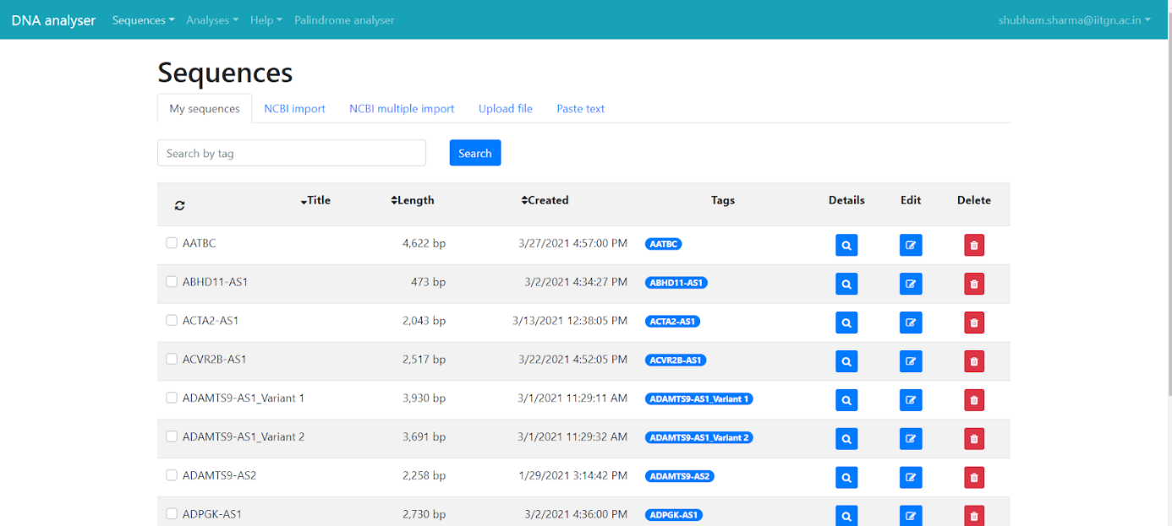

FIGURE – 16: List of sequences uploaded on G4 Hunter.

Further on, the Analysis settings were maintained at a window size of 45 and each sequence (and variants, if any) were observed at thresholds 0.9 and 1.4 respectively. This was done to ensure that high-scoring PQS (mostly 3G and 4G) were not overlooked at a lower threshold score – for example, a 4G PQS would score between 1.00 and 1.4, so each series was examined at both threshold values to ensure that these 3G or 4G PQS were taken into account.

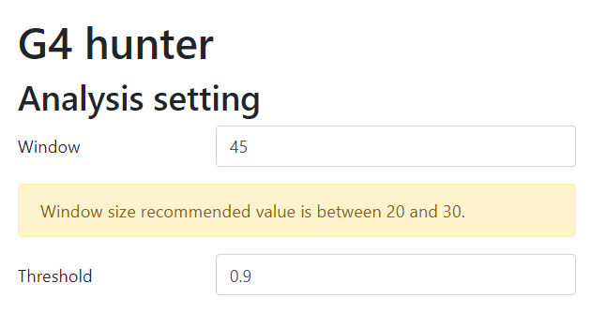 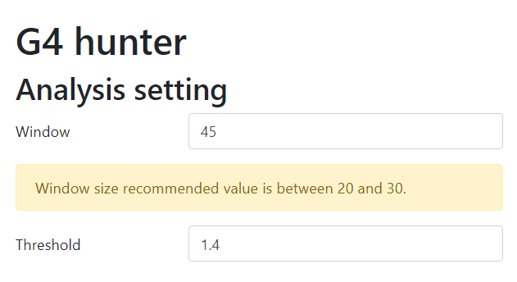

FIGURE – 17: G4 Hunter Analysis setting.

Upon analysis of each sequence, first a heatmap that divides the sequence and displays the number of G4-forming sequences in each segment shows up. The number of results is marked by the intensity of red and blue colours. The heatmap can be used to filter results in selected segments.

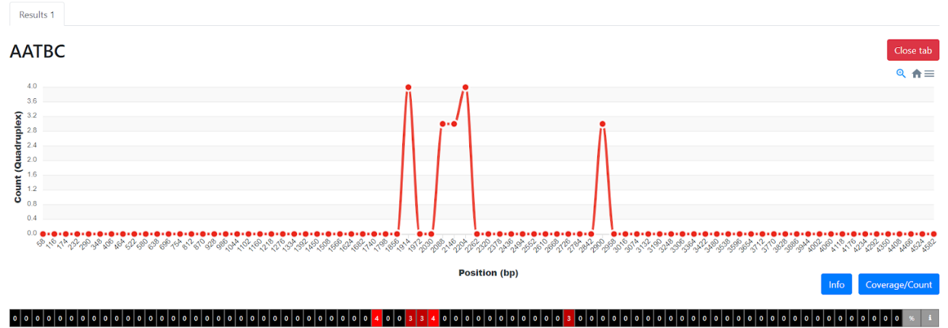

FIGURE – 18: G4 Hunter Analysis of lncRNA AATBC (Count vs position graph).

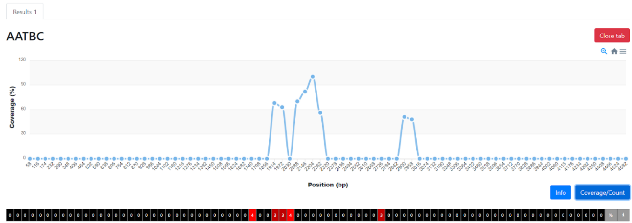

FIGURE – 19: G4 Hunter Analysis of lncRNA AATBC (Coverage vs position graph).

Basic information such as settings, number and frequency of results, export options, and sequence information such as duration and GC content can be found below the graphs. The nucleotide sequences of the results are shown in the sequence browser section, which also includes a cut-out of bases that matches the screen/browser window. Colours indicate the sequences that correspond to the analysis parameters (G in red—the longer the G-track, the brighter the intensity, C in blue). The sequence’s position, duration, sequence, score map, and G4Hunter score are all shown. C-rich sequences are scored negatively according to the scoring algorithm and can form G-quadruplexes in their complementary strands. [14]

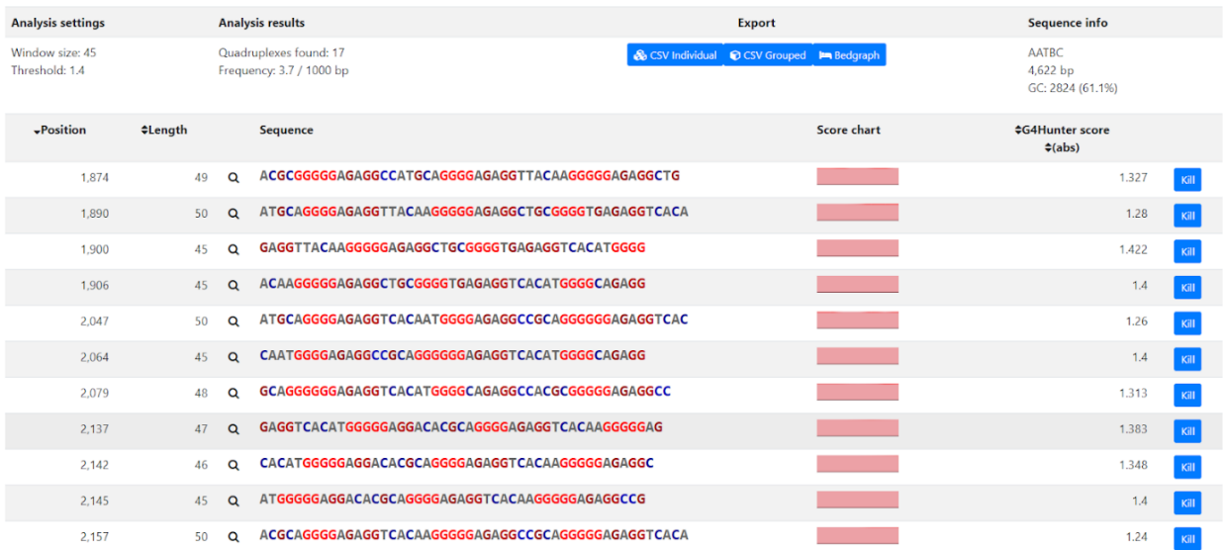

FIGURE – 20: List of G-quadruplexes predicted by G4 Hunter.

The magnifier icon is used to view divided data; the aggregated results are shown first.

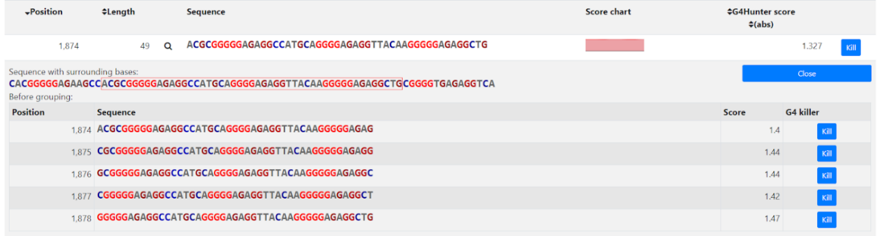

FIGURE – 21: List of overlapping sequences.

Results were also exported and collected as a text file for further processing. Shown below are parameters considered for collecting information for storing in the excel sheet.

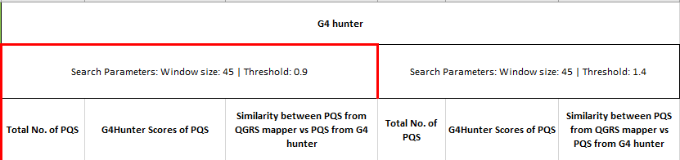

FIGURE – 22: Parameters considered for data collection in Excel.

**RESULT AND DISCUSSION**

Eight separate sheets were made for Gastric and Head and neck cancer respectively in order to create an accurate differentiation, an efficient display of data and to narrow down the exact number of potential lncRNAs in QGRS Mapper. The number of 2G, 3G and 4G PQS were calculated in each validated and reviewed lncRNA sequence. The validated and reviewed lncRNAs were highlighted in green and the rest in blue to create a proper distinction. Information obtained from the NCBI Nucleotide server was also inputted as shown in the images below.

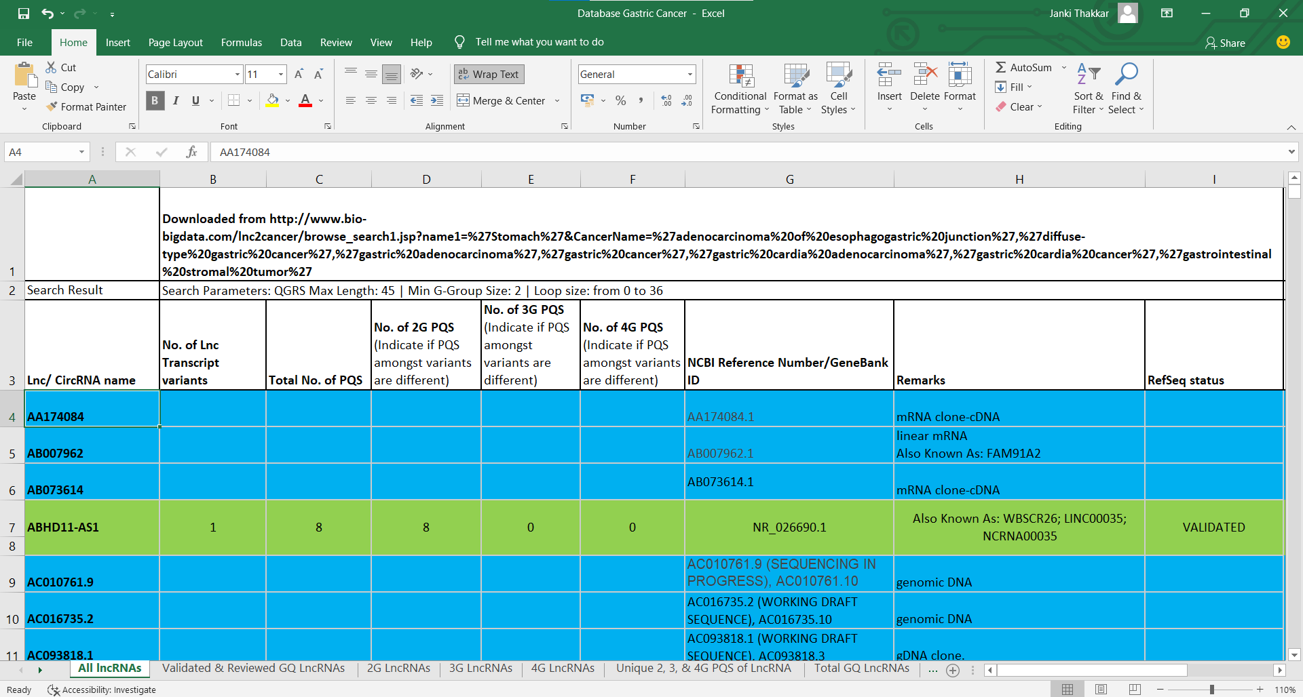

FIGURE – 23: Data collection for Gastric cancer.

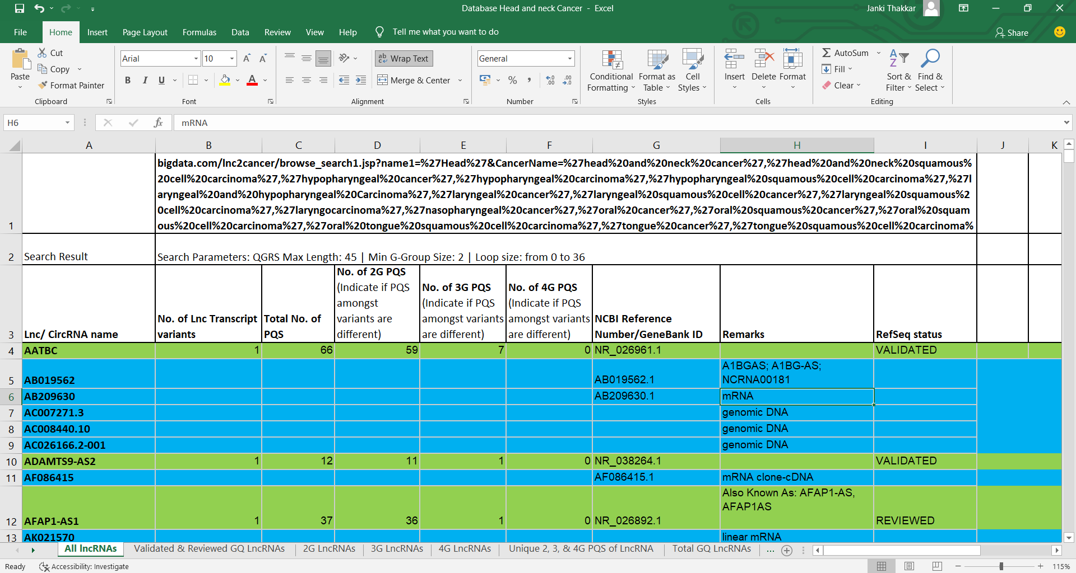

FIGURE – 24: Data collection for Head and neck cancer.

In Gastric cancer, out of a total of 593, 263 were lncRNAs. Further distinction is shown in the graphs below. There were 263 sequences that 2G tracts, 124 with 3G tracts and 7 with 4G tracts.

FIGURE – 25: Graph showing distribution of all the lncRNAs.

FIGURE – 26: Graph showing percentage distribution of all the lncRNAs.

FIGURE – 27: Pie chart showing percentage distribution of all the unique lncRNAs.

In lncRNAs containing 4G G-tracts, the PQS with higher G-scores are considered more stable when compared to the ones with a lower G-score.

FIGURE – 28: Graph showing distribution of lncRNAs having 4G G-tracts based on

their G-scores.

FIGURE – 29: Graph showing distribution of unique lncRNAs having 4G G-tracts based on their G-scores.

In Head and neck cancer, out of a total of 332, 156 were lncRNAs. Further distinction is shown in the graphs below. There were 164 sequences that 2G tracts, 80 with 3G tracts and 4 with 4G tracts.

FIGURE – 30: Graph showing distribution of all the lncRNAs.

FIGURE – 31: Graph showing percentage distribution of all the lncRNAs.

FIGURE – 32: Pie chart showing percentage distribution of all the unique lncRNAs.

In lncRNAs containing 4G G-tracts, the PQS with higher G-scores are considered more stable when compared to the ones with a lower G-score.

FIGURE – 33: Graph showing distribution of lncRNAs having 4G G-tracts based on

their G-scores.

FIGURE – 34: Graph showing distribution of unique lncRNAs having 4G G-tracts based on their G-scores.

In G4 Hunter, all the lncRNAs validated and reviewed during QGRS Mapper analysis were explored at two different thresholds – 0.9 and 1.4, in order to find sequences with a G-score value higher than that. The window size was kept as 45. Out of 263 lncRNAs of Gastric cancer, there were 130 and 5 lncRNAs with 2G tracts at thresholds 0.9 and 1.4 respectively. 69 and 33 lncRNAs were found having 3G tracts at thresholds 0.9 and 1.4 respectively. 7 and 4 lncRNAs were found having 4G tracts at thresholds 0.9 and 1.4 respectively.

FIGURE – 35: Graph depicting the PQS distribution for Gastric cancer lncRNAs obtained from G4 Hunter.

Out of 156 lncRNAs of Head and Neck cancer, there were 83 and 2 lncRNAs with 2G tracts at thresholds 0.9 and 1.4 respectively. 56 and 26 lncRNAs were found having 3G tracts at thresholds 0.9 and 1.4 respectively. 5 and 4 lncRNAs were found having 4G tracts at thresholds 0.9 and 1.4 respectively.

FIGURE – 36: Graph depicting the PQS distribution for Head and neck cancer lncRNAs obtained from G4 Hunter.

LncRNA AND G4 INTERACTING PARTNERS

As discussed previously, HOXC-AS3 potentially regulates a group of genes related to cell proliferation and migration in Gastric cancer, including MMP7, WNT10B, HDAC5 and others, by binding to YBX1. [6] This led to an exploration into databases showing lncRNA-interacting partners (LncRNome, LncTarD, NPInter 4.0) and G-quadruplex interacting partners (G4IPDB).

Shown below are the hits displayed by LncRNome, upon looking for protein-protein interactions of HOXC-AS3. The table shows different transcripts of the lncRNA along with its location on the chromosome.

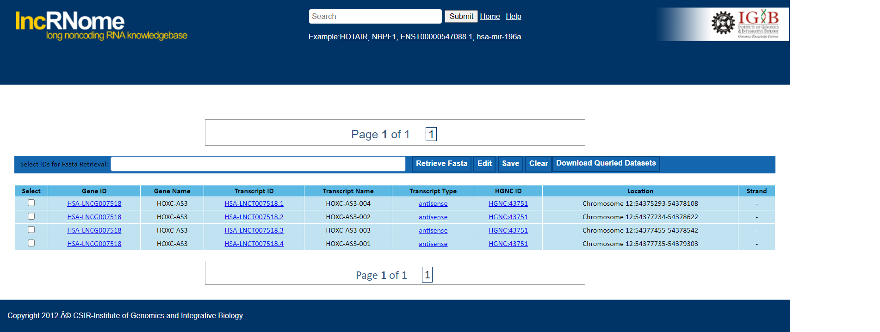

FIGURE – 37: LncRNome hits for HOXC-AS3.

Upon clicking on any of the Transcript IDs, a variety of information on it appears. This includes its general information, a display of its sequence and structure, all of the transcript’s interactions and processing, variations and conservation, and epigenetic modifications.

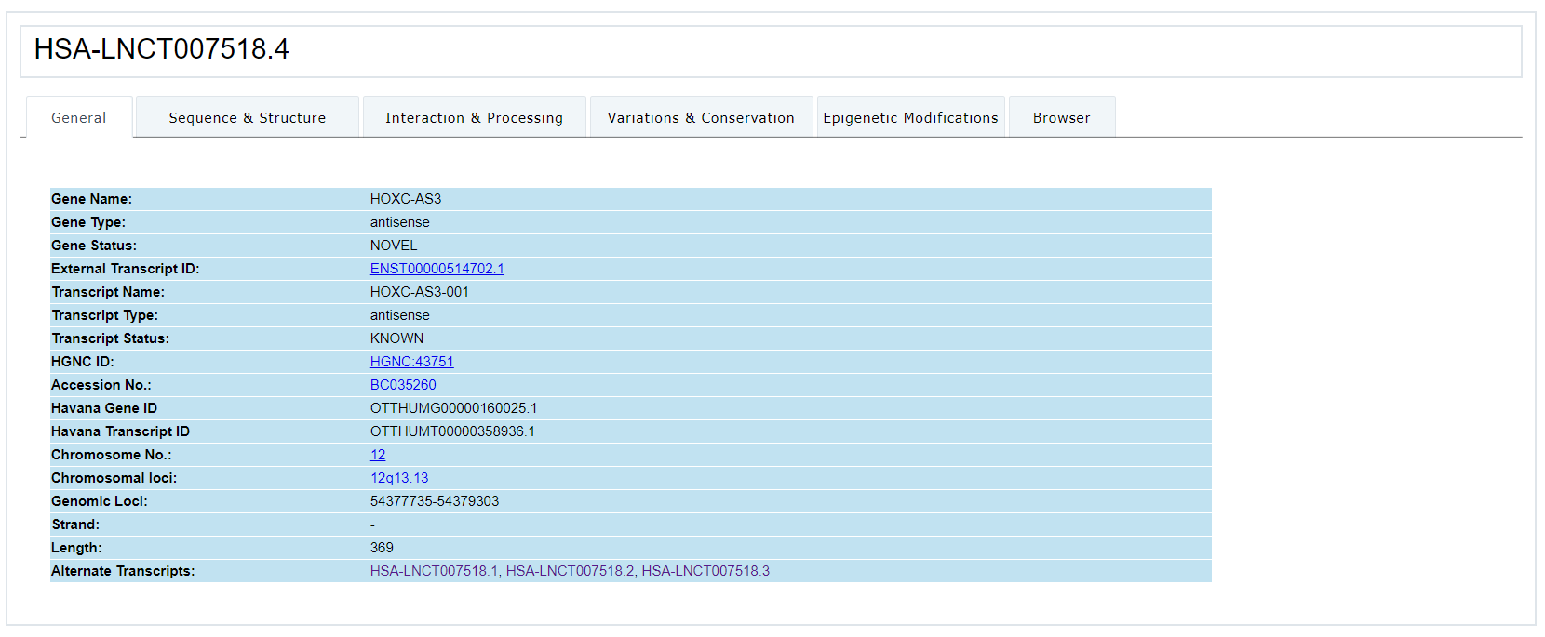

FIGURE – 38: HOXC-AS3 Transcript general information.

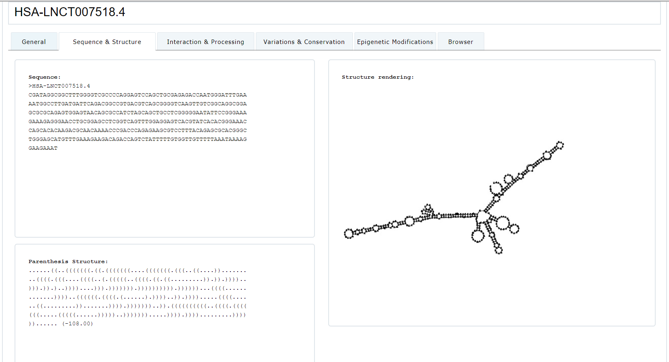

FIGURE – 39: HOXC-AS3 Transcript sequence and structure.

The same lncRNA was further analyzed in LncTarD to reveal search results in the form of basic information as displayed in the image below.

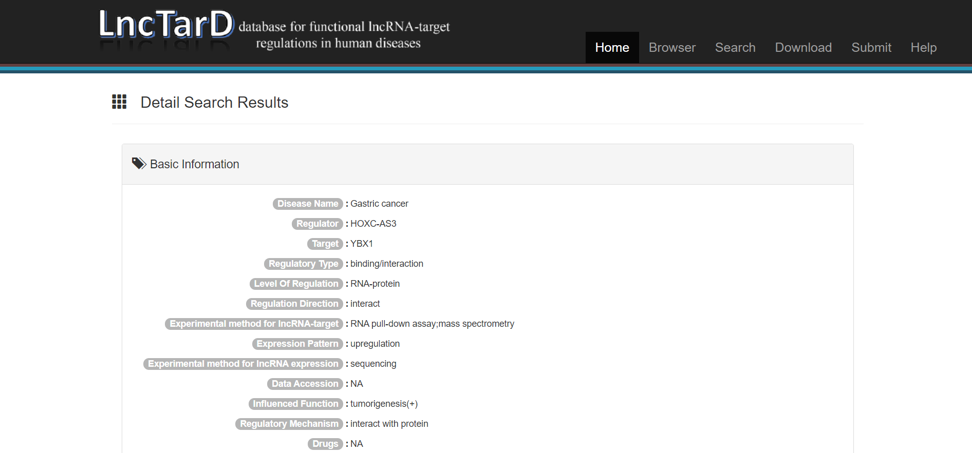

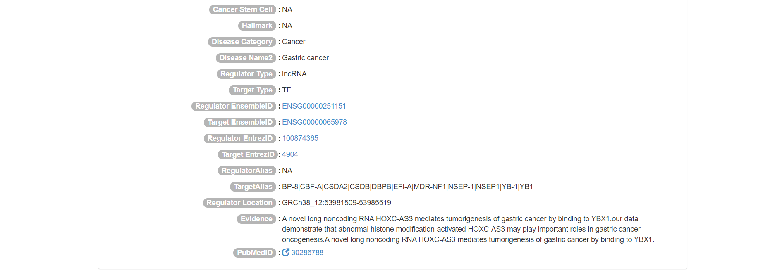

FIGURE – 40: LncTarD hits for HOXC-AS3.

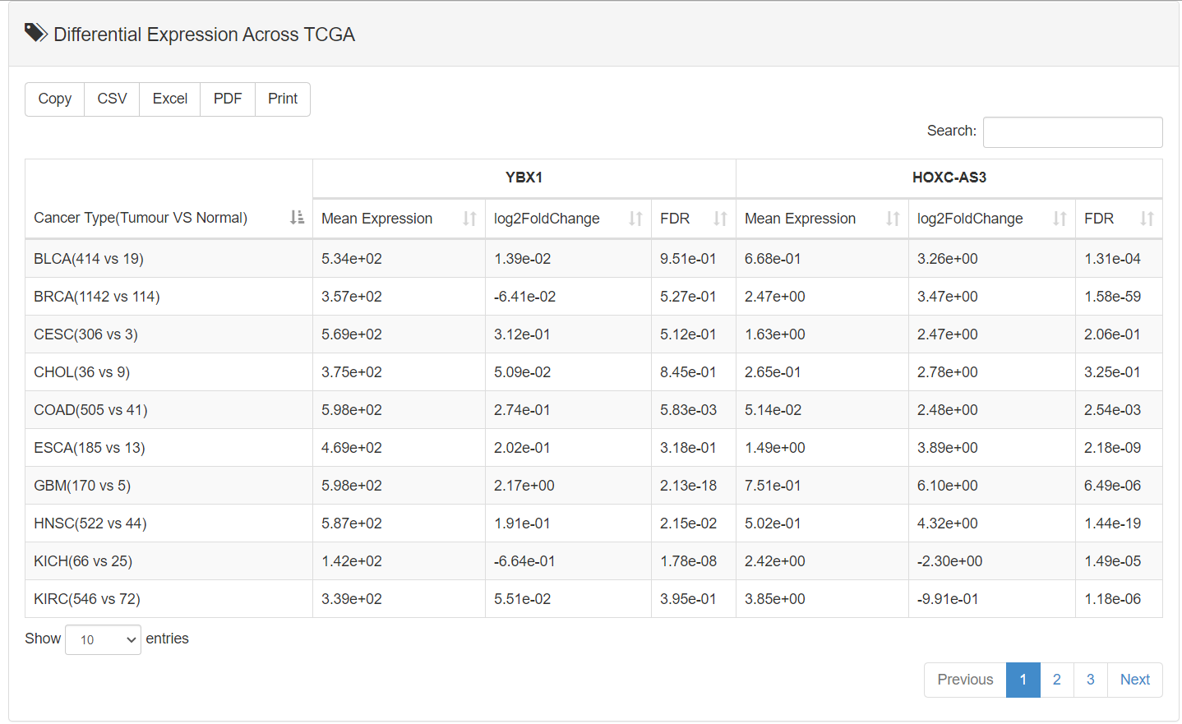

FIGURE – 41: Table showing different expressions of HOXC-AS3 and YBX1 in different cancer types.

Providing a more detailed review of how HOXC-AS3 interacts with YBX1, this database shows boxplot displays of expression of YBX1 and HOXC-AS3 in normal and cancer cells respectively, along with an expression correlation heatmap and a Scatter plot of how these interactions would be expressed in different cancer types.

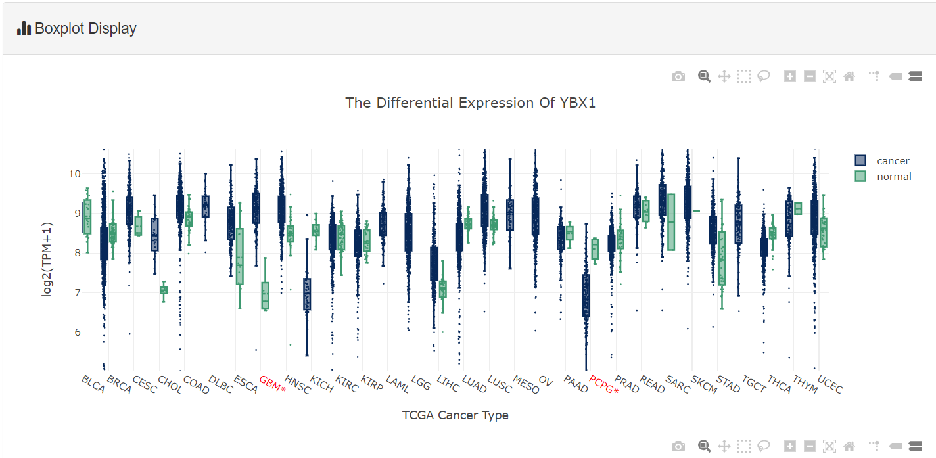

FIGURE – 42: Boxplot display for YBX1.

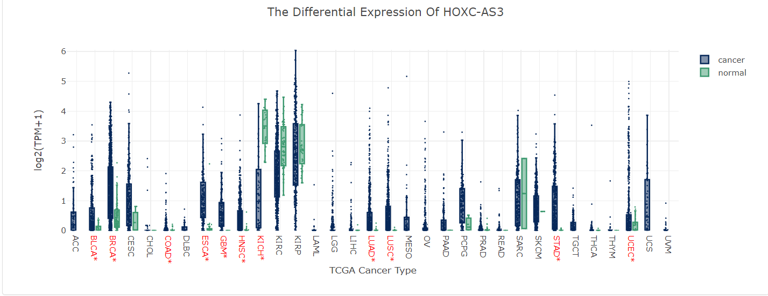

FIGURE – 43: Boxplot display for HOXC-AS3.

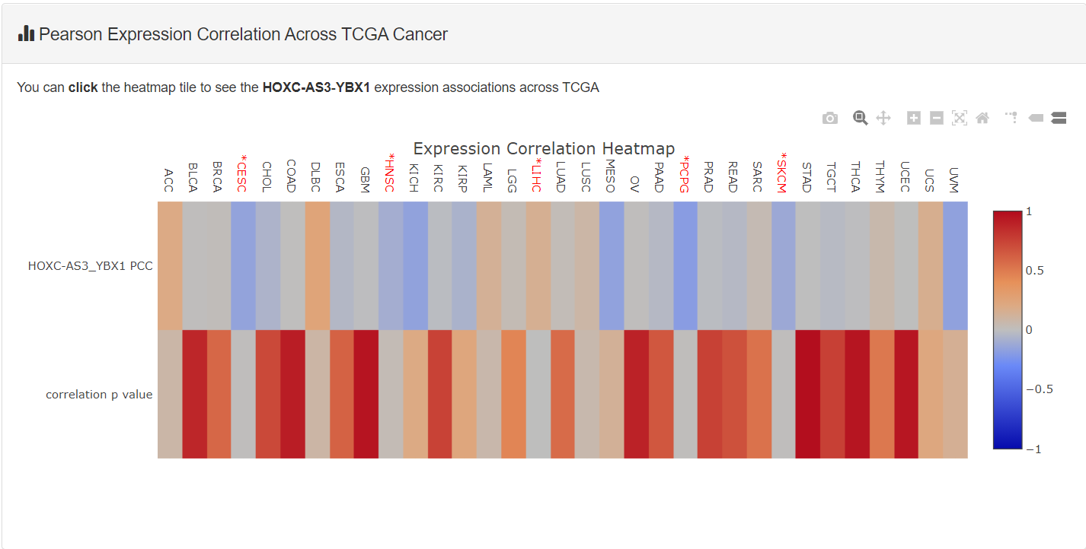

FIGURE – 44: HOXC-AS3-YBX1 expression correlation heatmap.

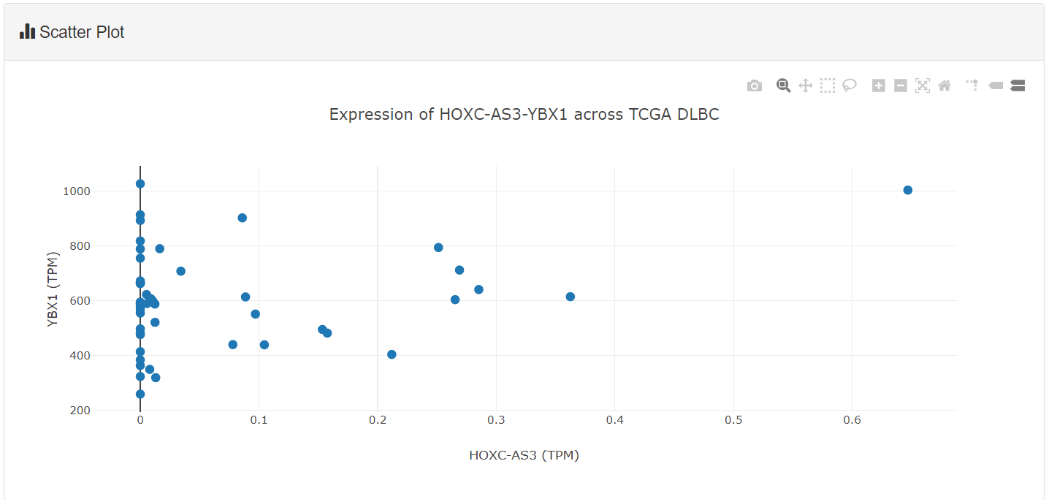

FIGURE – 45: HOXC-AS3-YBX1 expression scatter plot.

NPInter showed limited data in the form of interaction information – naming the targets and providing interaction descriptions but it did not show any data about HOXC-AS3 and YBX1 interaction. In fact, it only showed one protein-protein interaction for gastric cancer.

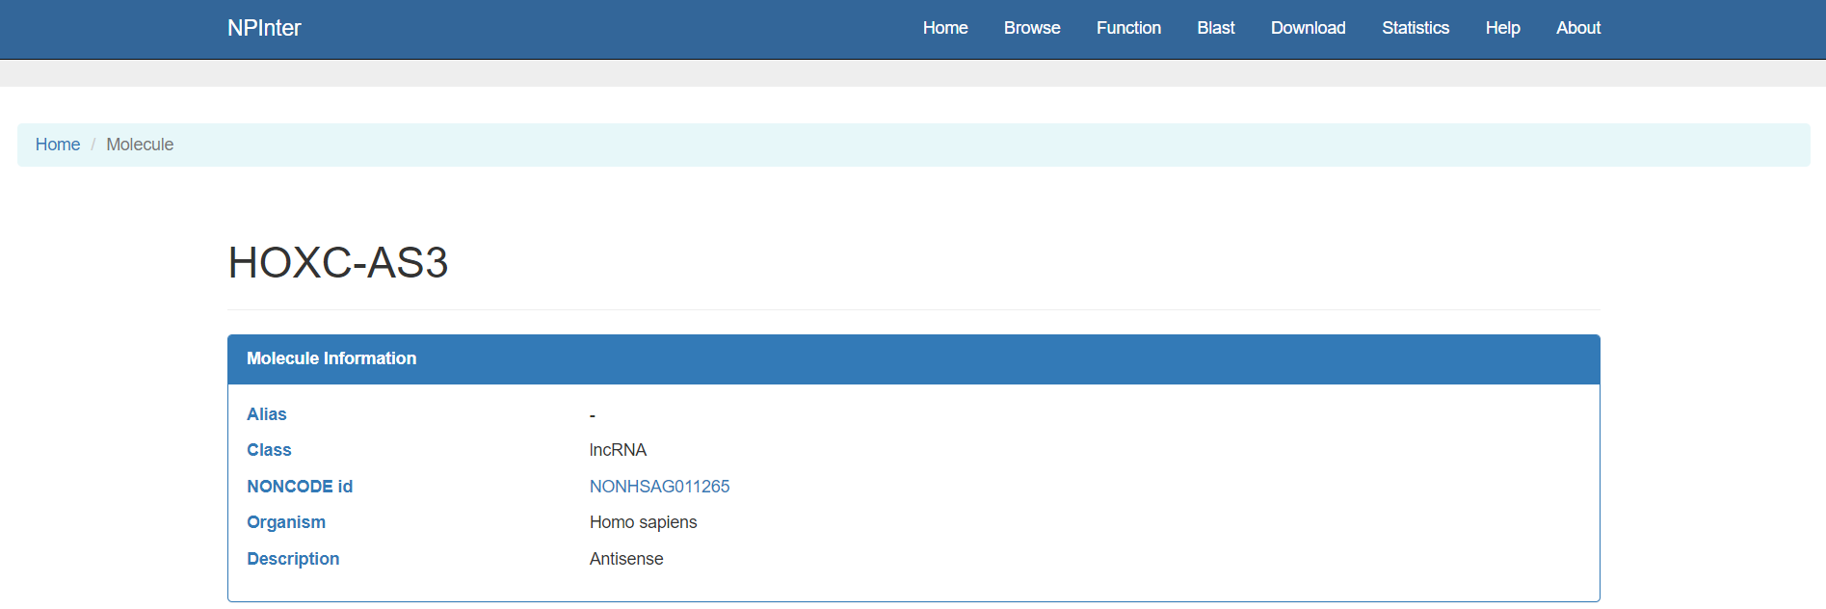

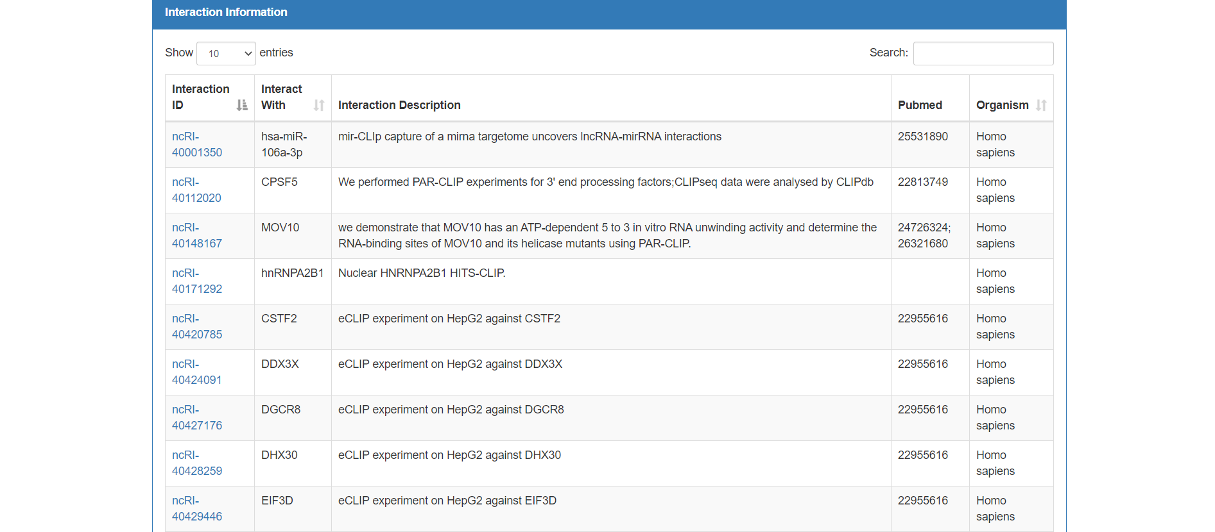

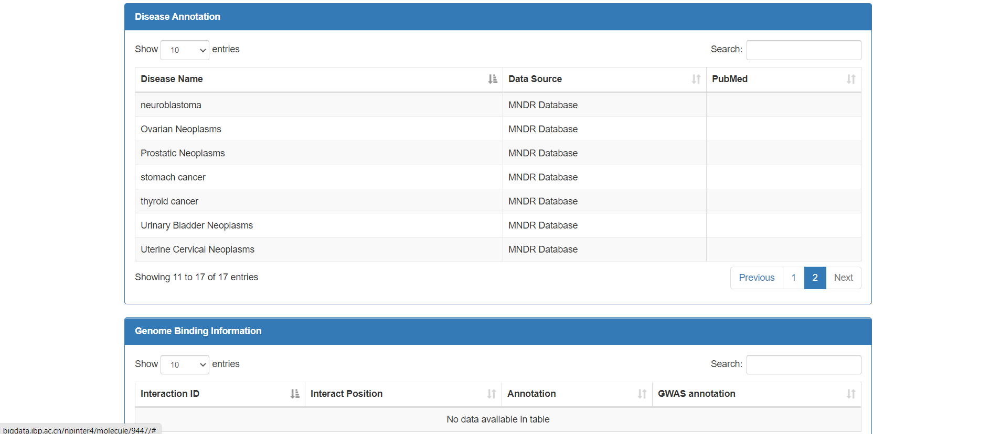

FIGURE – 46: Interaction information displayed on NPInter.

Looking for the protein YBX1 on G4IPDB, one can easily find all relative information on the database server, along with links to the protein on its UniProt and PubMed pages.

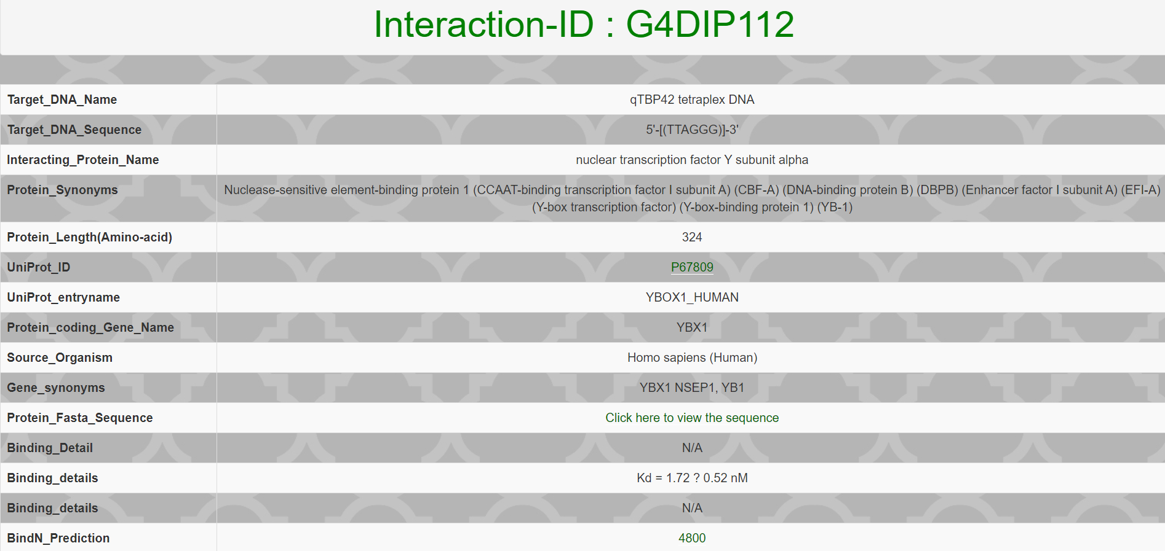

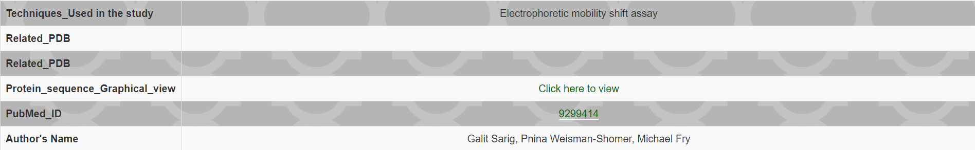

FIGURE – 47: Information about YBX1 on G4IPDB.

**CONCLUSION**

To summarize, the lncRNA databases investigated during the course of this project provide a wealth of knowledge. In terms of large annotation detail, primarily on quadruplex formations, the results retrieved are identical. Complementarity in molecular association functionality can also be found in generic lncRNA databases. Diverse knowledge could be collected for both well-known and novel lncRNAs, which could be useful in expanding the characterization of their possible functional mechanisms. Overall, these findings suggest that these tools can be used to help or even push experimental research.

**FUTURE PERSPECTIVE OF RESEARCH STUDY**

Bioinformatic studies have been able to enumerate and classify several unusual possible sequence motifs, as well as reveal how potential quadruplex sequences are distributed in terms of nucleic acid function on a variety of levels. There are a lot of different sequences that could theoretically form G-quadruplex structure motifs. In contrast, the number of sequences known to form G-quadruplex structures, as well as the total number of sequences that are assumed not to form quadruplex structures, is extremely limited.

It’s easy to misinterpret the effects of quadruplex sequence searches. There’s a risk that, in the absence of evidence indicating another explanation for a possible quadruplex sequence’s existence, this would be taken as proof of quadruplex structure. Conservation of motifs through organisms, for instance, suggests the biological importance of a functional system but does not provide evidence for the system’s mechanism of action. Potential quadruplex sequences are caused by factors other than quadruplex structure, and these should be considered before assuming that selective pressure for quadruplex structure is responsible for their nature.

The field of quadruplex sequence bioinformatics is still in its infancy. Sequence searches may be used to find potential quadruplex sequences, but experimental evidence is needed to establish if they fold into real quadruplex structures. Current search patterns based on telomeric-like quadruplex topologies are a good place to start when trying to figure out where quadruplex sequences are located. However, they may overlook a number of quadruplex structures that do not involve the traditional four-guanine-run pattern.

There is also the fact that a majority of data obtained is dissimilar when it comes to protein-interacting partners. As seen in the example performed, each database provided a variety of information based on the literature available but there is also the fact that the intersection and overlap between these source PPI databases are relatively small. It does not provide a wholesome display of results. All these speculations can only be confirmed when the data about protein-protein interactions is integrated and unified in a common and comparative platform with a set of built-in tools for network construction, analysis, filtering and visualization.

The work done in this project towards creating a novel database is an attempt to collect and display comprehensive data and is only the first step. More research into these lncRNAs should be done in the context of experimental study, with the aim of at least proving their potential importance in biological processes other than cancer therapies. This data will improve the confidence of protein-protein interactions and the corresponding PPI network when used collectively. The indagation shown with the lncRNA cancer database, QGRS Mapper, G4 Hunter, and lncRNA and G4-interacting partners can be further explored by using more advanced tools, and this may become one of the most influential steps to treat different cancers.

**REFERENCES**

1. Agarwala, P., Pandey, S., & Maiti, S. (**2015**). The tale of RNA G-quadruplex. *Organic and Biomolecular Chemistry*, *13*(20), 5570–5585.

2. Peng, Y., & Croce, C. M. (**2016**). The role of microRNAs in human cancer. *Signal Transduction and Targeted Therapy*. Springer Nature.

3. Tassinari, M., Richter, S. N., & Gandellini, P. (**2021**). Biological relevance and therapeutic potential of G-quadruplex structures in the human noncoding transcriptome. *Nucleic Acids Research*, *49*(7), 3617–3633.

4. RNA | Definition, Structure, Types, & Functions | Britannica. (n.d.). Retrieved May 14, 2021.

5. Long Noncoding RNAs in Cancer Pathways | Elsevier Enhanced Reader. (n.d.). Retrieved May 14, 2021.

6. Tan, H., Zhang, S., Zhang, J., Zhu, L., Chen, Y., Yang, H., … Liu, B. (**2020**). Long non-coding RNAs in gastric cancer: New emerging biological functions and therapeutic implications, *10*(19), 8880–8902.

7. Gao, Y., Wang, J.-W., Ren, J.-Y., Guo, M., Guo, C.-W., Ning, S.-W., & Yu, S. (**2020**). Long noncoding RNAs in gastric cancer: From molecular dissection to clinical application Conflict-of-interest statement. *World J Gastroenterol*, *26*(24), 3401–3412.

8. Wang, Y., Wang, S., Ren, Y., & Zhou, X. (**2020**, October 2). The Role of lncRNA Crosstalk in Leading Cancer Metastasis of Head and Neck Squamous Cell Carcinoma. *Frontiers in Oncology*. Frontiers Media S.A.

9. Desai, N., Shah, V., & Datta, B. (**2021**). Assessing G4-Binding Ligands In Vitro and in Cellulo Using Dimeric Carbocyanine Dye Displacement Assay. *Molecules (Basel, Switzerland)*, *26*(5), 1–16.

10. Kosiol, N., Juranek, S., Brossart, P., Heine, A., & Paeschke, K. (**2021**, December 1). G-quadruplexes: a promising target for cancer therapy. *Molecular Cancer*. BioMed Central Ltd.

11. Nakanishi, C., & Seimiya, H. (**2020**). G-quadruplex in cancer biology and drug discovery. *Biochemical and Biophysical Research Communications*, *531*(1), 45–50.

12. Wei, L., Sun, J., Zhang, N., Zheng, Y., Wang, X., Lv, L., … Yang, M. (**2020**, March 19). Noncoding RNAs in gastric cancer: Implications for drug resistance. *Molecular Cancer*. BioMed Central Ltd.

13. Kikin, O., D’Antonio, L., & Bagga, P. S. (**2006**). QGRS Mapper: A web-based server for predicting G-quadruplexes in nucleotide sequences. *Nucleic Acids Research*, *34*(WEB. SERV. ISS.), 676–682.

14. Bedrat, A., Lacroix, L., & Mergny, J. L. (**2016**). Re-evaluation of G-quadruplex propensity with G4Hunter. *Nucleic Acids Research*, *44*(4), 1746–1759.

15. Puig Lombardi, E., & Londoño-Vallejo, A. (**2020**, January 10). A guide to computational methods for G-quadruplex prediction. *Nucleic Acids Research*. Oxford University Press.

16. Rao, V. S., Srinivas, K., Sujini, G. N., & Kumar, G. N. S. (**2014**). Protein-Protein Interaction Detection: Methods and Analysis. *International Journal of Proteomics*, *2014*, 1–12.

17. Bhartiya, D., Pal, K., Ghosh, S., Kapoor, S., Jalali, S., Panwar, B., … Scaria, V. (**2013**). LncRNome: A comprehensive knowledgebase of human long noncoding RNAs. *Database*, *2013*.

18. Zhao, H., Shi, J., Zhang, Y., Xie, A., Yu, L., Zhang, C., … Li, X. (**2020**). LncTarD: a manually-curated database of experimentally-supported functional lncRNA-target regulations in human diseases. *Database issue Published online*, *48*.

19. Mishra, S. K., Tawani, A., Mishra, A., & Kumar, A. (**2016**). G4IPDB: A database for G-quadruplex structure forming nucleic acid interacting proteins.